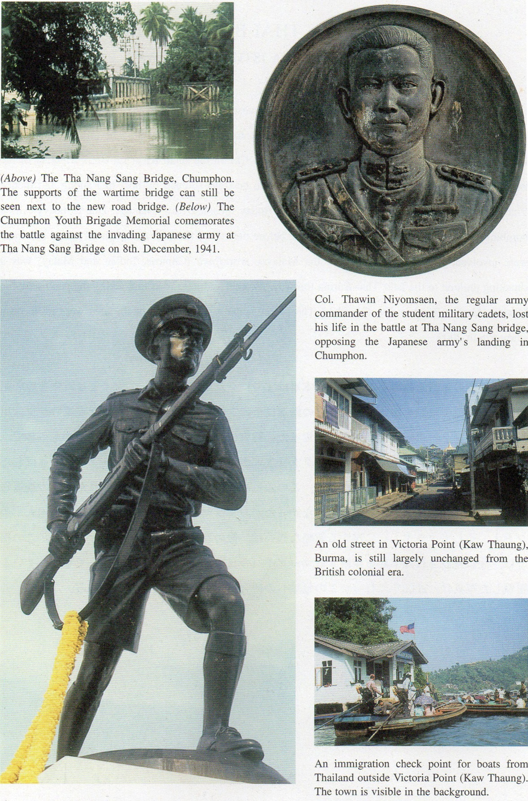

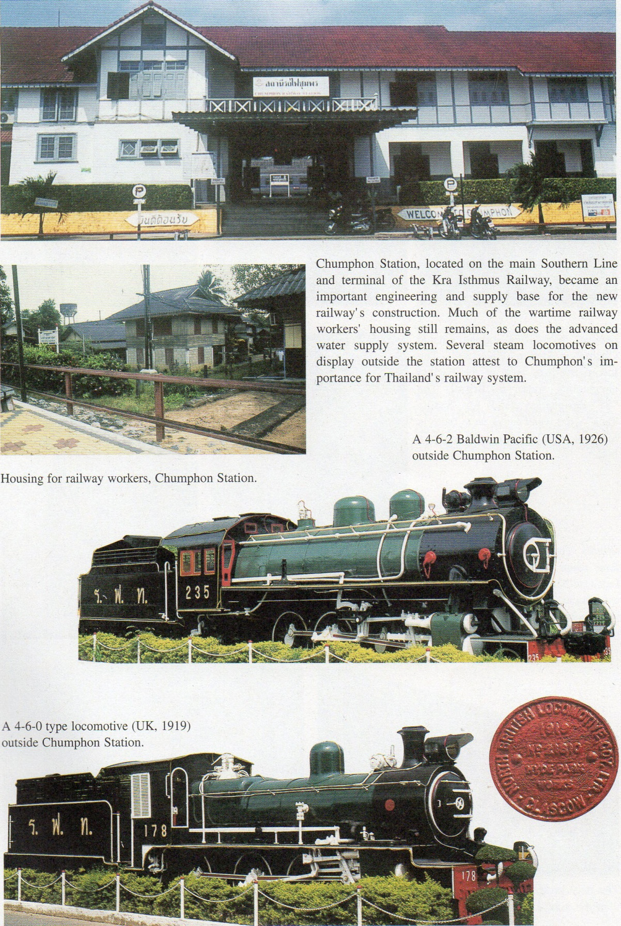

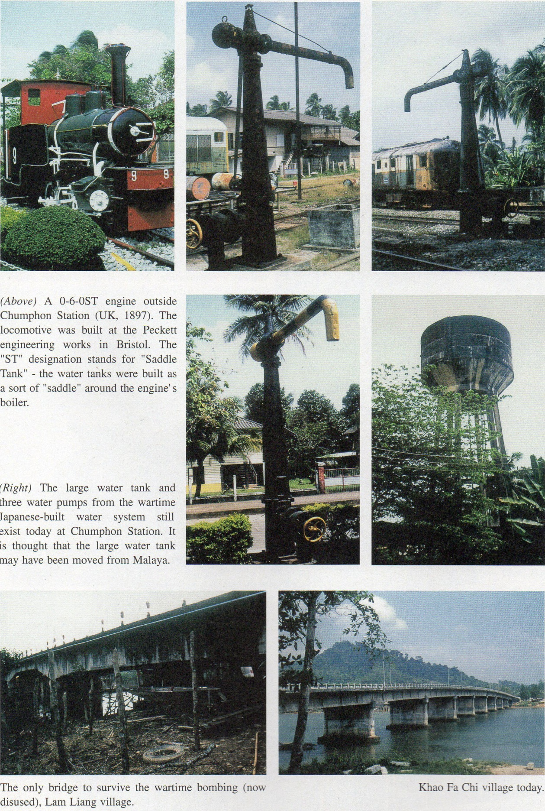

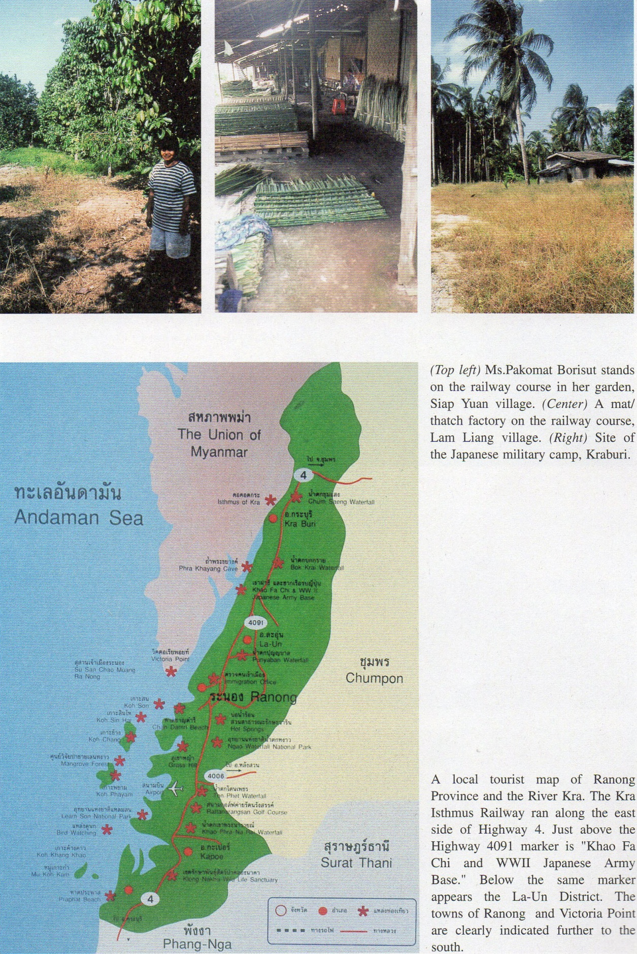

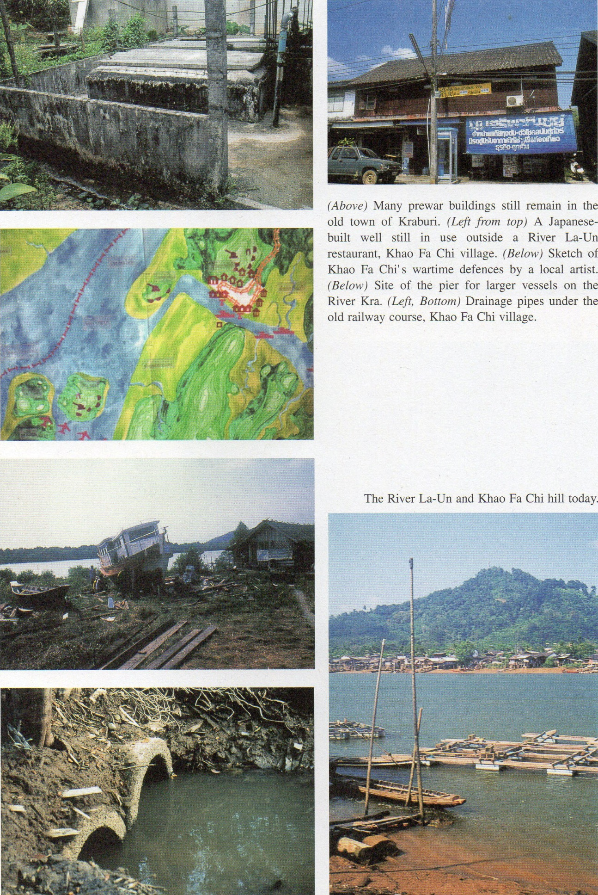
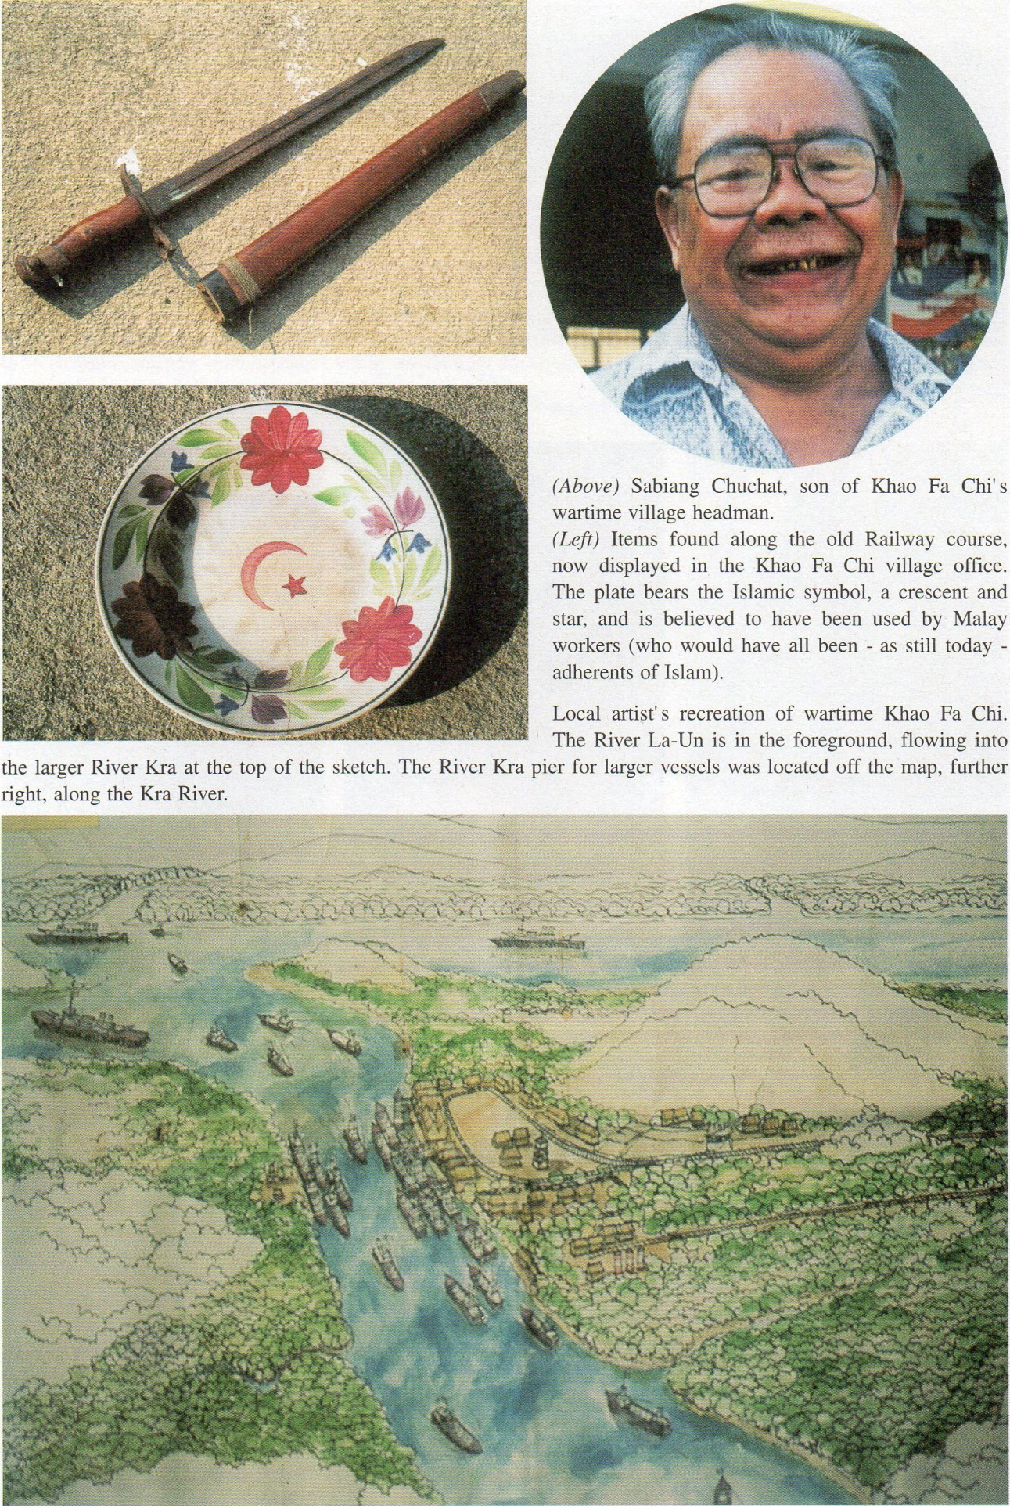
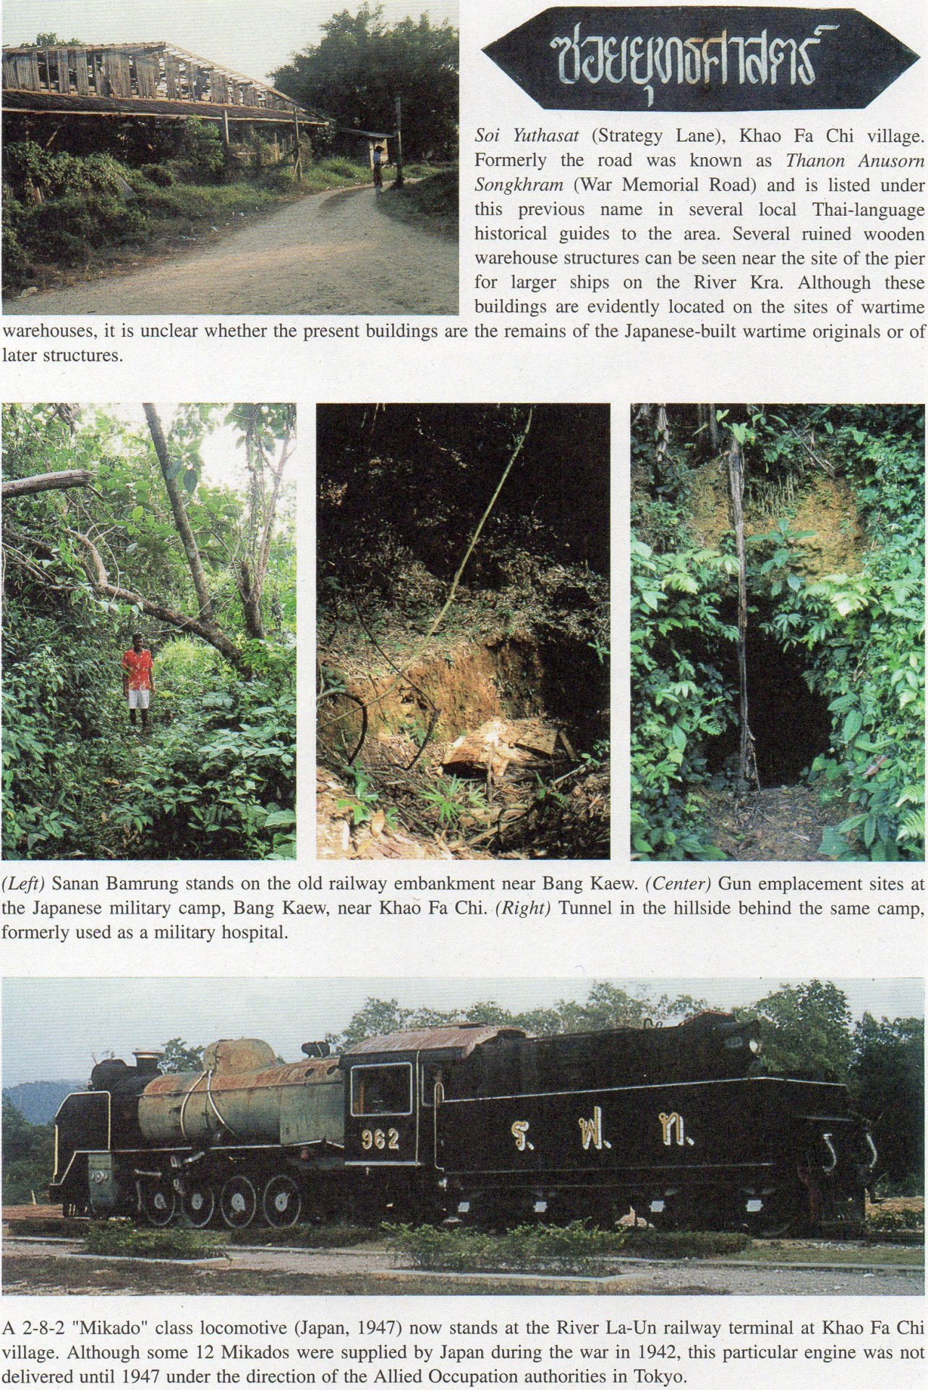
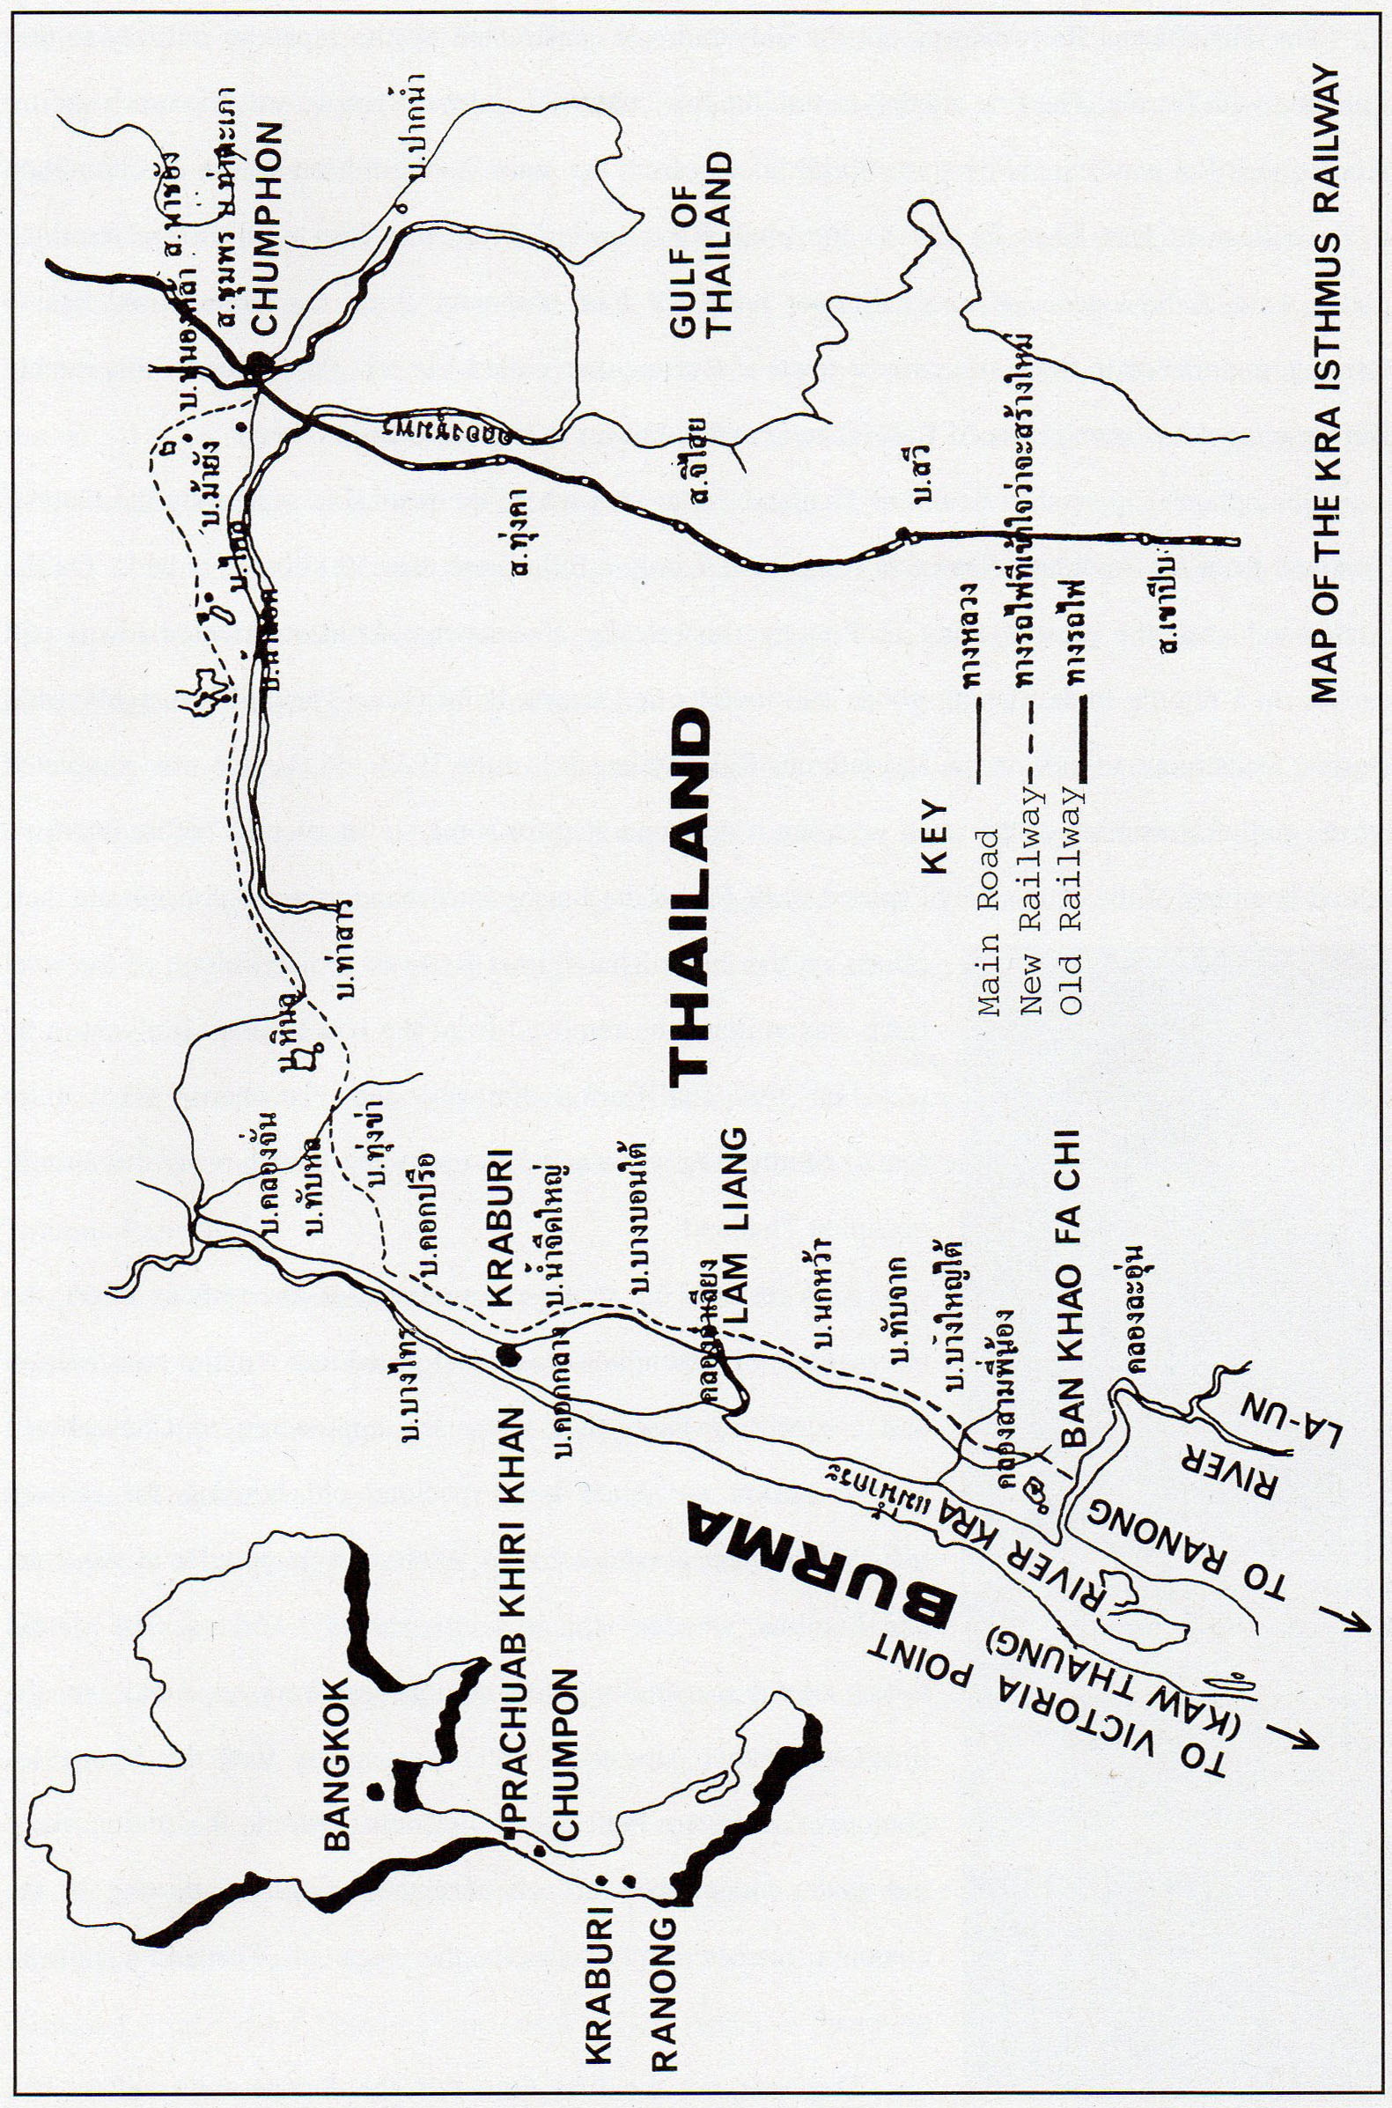
This map of the Kra Isthmus Railway id based upon that by Praphan Phonsawek in Sinlapa Wathanatham (Art & Culture Magazine0; Vol.12, No.8 (1991); p.107.

NOTES ON THE THAI-BURMA RAILWAY
PART IX: THE KRA ISTHMUS RAILWAY
The Thai-Burma Railway was not the only railroad constructed by the Japanese military to link Thailand with Burma. The first completed attempt to link the two countries’ railroad systems was the much shorter Kra Isthmus Railway, extending some 90 kilometers from the main Southern Line station of Chumphon to the village of Ban Khao Fa Chi on the small River La-Un. From this Thai rural village terminal, goods were to be loaded on to small river boats for trans-shipment along the River La-un and the larger River Kra to Ranong, and thence to the southernmost town of Burma, then called Victoria Point. Today, this sizable Burmese town has been renamed Kaw Thaung and is known to the Thais as Ko Song.
Chumphon is located in Southern Thailand, in an area where the peninsula separating the Gulf of Thailand from the Andaman Sea is, in some places, only a little more than 50 kilometers wide. On the Andaman coast, the present town of Ranong (historically a somewhat Chinese-oriented town) still carries on a regular trade of both goods and tourists to Victoria Point (Kaw Thaung) in neighbouring Burma. Construction work on the Kra Isthmus Railway began in June 1943 and the line was completed by the end of November of the same year, but it only operated for some eleven months before intensive Allied bombing of the extensively exposed track forced the Japanese to abandon it and concentrate their efforts on the larger Thai-Burma Railway project. Much of the steel track was at that time removed from the Kra Isthmus Railway to be used on the Thai-Burma Railway and elsewhere. What little remained after the war was taken up by the British army that briefly occupied Thailand.
As a result of its strategic importance to the railway effort, the sleepy town of Chumphon was transformed into a major construction and engineering base. Still today the approaches to Chumphon’s sizable station are lined with spacious old housing for railway officials, built in a semi-colonial Western style popular at the time, and humbler wooden tenements for railway workers. The station boasts a large marshalling yard, engineering workshops and - for the times - a rather advanced water system to fuel the steam locomotives, a system built by the Japanese. Outside the station, three old steam locomotives are on permanent display, attesting to the station’s former importance in the saga of Thailand’s railway system.
This was not the first time that the Japanese war effort had impinged upon the lives of Chumphon’s citizens. On the 8th December 1941, a detachment of the invading Japanese army had landed at one of Chumphon’s many inlets, only to encounter resistance from a Thai student military unit raised from the students of the Sriyaphai High School. Their regular commanding officer, Colonel Thawin Niyornsaen, lost his life in the ensuing skirmishes at the Tha Nang Sang Bridge and the nearby Wat Tha Yang Tai temple. Col. Thawin’s second-in-command, Lieutenant Samran Kuanphan (then a sergeant) also lost his right arm up to the elbow. Sometime after the war, Lt. Samran contacted the youth brigade s leader, Thepthai Chaisomkhon, who gathered the other former student soldiers in order to erect a small memorial to those involved in opposing the Japanese army’s landing. In 1981, with financial assistance from the Chumphon local government and Col. Thawin’s son, the memorial was restored, enlarged and moved to its present location beside the old Tha Nang Sang Bridge. The gist of the commemorative inscription on the monument begins,
“A youth brigade in the uniform of the Chumphon military cadets demonstrated their bravery before all the people when, despite their small numbers, their courageous stand delayed the invading (Japanese) army from entering Chumphon Province. This is a glorious history and will not be forgotten.... (This monument) is dedicated to their courage and valour that it will he forever remembered by all.”
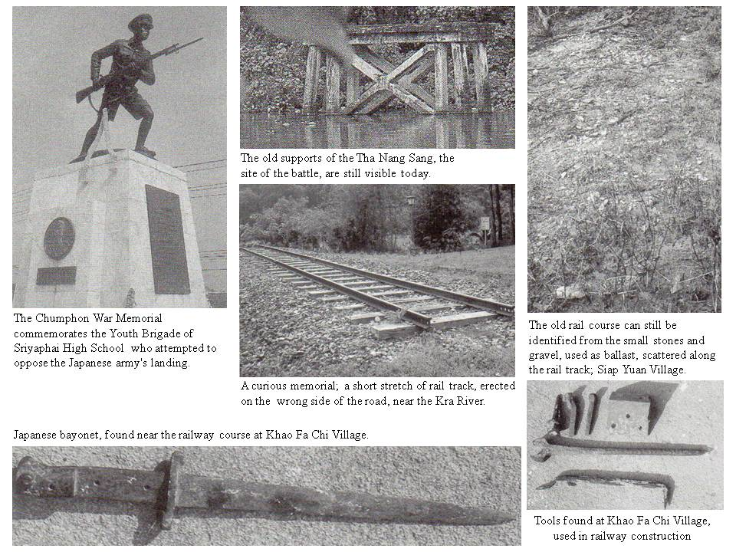
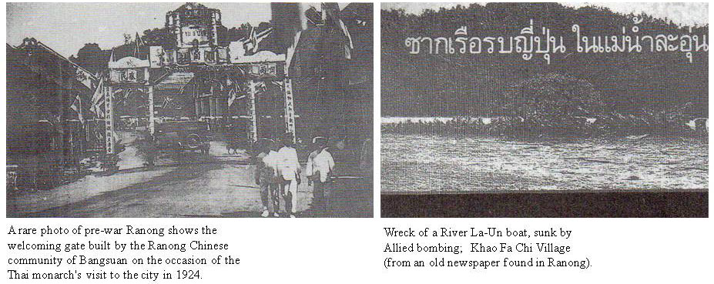

Against this background, it is unlikely that Chumphon’s inhabitants were particularly elated to hear that their town had been selected as the Japanese army’s base of operations for construction of the Kra Isthmus Railway. Few records of the railway’s construction survive, the only substantial account of the railway being that (in Thai language) by Praphan Phonsawek which appeared in the June 1991 edition of the “Sinlapa Wathanatham” (Art & Culture) Magazine. Praphan traces
the process of negotiations which led to an agreement to build the
railway between a Col. Yamada (presumably Military Attaché of the Japanese Embassy in Bangkok) and Phisit Disaphong Ditsakul representing the Thai government. The negotiations were held in Yamada’s house on Wireless Road. Under the agreement, Thailand was to prepare the earthworks for the rail course, build bridges and undertake the necessary drainage system to prevent the heavy monsoon rains from flooding the track. The Japanese were to provide the labour for laying the sleepers, the track itself and construction of related facilities. Japan also undertook to provide the steel rail track from the Malayan railway system in Kelantan and provide technical staff (also from Malaya) to operate the railway when finished.
The agreement was formally signed by Thai Prime Minister Plaek Phibunsongkhram and General Nakamura Aketo of the (Japanese) Bangkok Garrison Command. Interestingly, anticipating Thailand’s agreement, the Japanese had already made a thorough survey of the railway’s projected course. It seems that the Japanese side was somewhat elated; having obtained Thailand’s agreement to undertake rather more of the construction work than had at first been anticipated. The Thai government immediately contracted their share of the work out to private (Thai) contractors who endeavoured to employ chiefly Thai-Chinese labour. Although conditions for those workers employed by the Thai contractors were infinitely better than for the labourers conscripted by the Japanese army, Thai company officials nevertheless had great difficulty in persuading their workers to stay longer than one or two months and were constantly seeking new recruits.
The Japanese, for their part, had determined that not only the rail track and operating technicians were to come from Kelantan, but also that the labour for track-laying and construction of the related railway and port facilities would he obtained - voluntary or otherwise - from Malaya; most informed estimates vary between 60,000 to 120.000 persons. Some Western commentators have claimed that Western prisoners-of-war (POWs) were also used as labourers on the Kra Isthmus Railway. However, there is no evidence to support this assertion (nor do any published POW diary accounts make any claim to having worked on the Kra Isthmus Railway). Rather, information from local informants suggests that, in a harrowing prelude to the excesses of the later Thai-Burma Railway, unencumbered by the niceties of any international agreements and not fearing postwar reprisals for their treatment of Asian civilians, the Japanese were quite prepared, if necessary, to work their Malayan labourers literally to their deaths. Praphan Phonsawek’s informants repeatedly state that work continued on a 24-hour day basis, that there were neither doctors nor medicines available; that the food was totally inadequate and that distressed Malayans - knowing neither the local nor the Japanese languages - who tried to abscond, were severely dealt with. The numerous dead were simply buried in shallow holes by the side of the rail tracks.
In January 2003 a research visit to the area and travel along the length of the old railway course confirmed that the rail track had run, by and large, alongside the present main road from Chumphon to Ranong: the old rail course was easily established from local informants, although - due to postwar internal migration to other parts of Thailand - very few people in the area today have direct memories of
construction. Not far from Chumphon, in Siap Yuan village, Ms. Pakomat Borisut indicated where the railway had run through her present garden: the course was clear from the gravel and small stones (used as ballast for the sleepers and track) that still lay scattered along the old rail course. Further west, at a site commemorating King Chulalongkorn’s allegedly having carved his initials on a rock face during a royal visit to the area, a short section of rail track has been re-laid, actually on the opposite side of the road to where the old railway had originally run. (Probably the old locomotive now displayed at the Khao Fa Chi village rail terminal - and mentioned below - had originally stood on this rail section). A local merchant in the old town of Kraburi arranged an exhaustive bike tour of the railway course, pointing out the area of the former army base (which had housed some 600 Japanese troops) and other related sites: the railway had not at first utilised the river port facilities that exist in the town along the Kra River and trains had stopped only briefly here to replenish supplies of fuel and water. At Lam Liang village a small rush mat and thatch-making factory sits astride the old rail line: an elderly local resident indicated the old bridge which had been bombed (the only old road bridge still in existence, for the bomb had failed to explode). Now disused, a more modem structure carries today’s traffic to the side of the old bridge site.

At the railway’s terminus in Khao Fa Chi village, the local administration has tried to reconstruct some sites connected with the railway. Efforts have been made to preserve some of the old warehouse sites at the River Kra port (for larger boats) and the harbour for smaller craft at the River La-Un terminal. An old steam locomotive has been positioned here to recreate the atmosphere of the old rail terminal. However, somewhat paradoxically, the engine is a Japanese 2-8-2 “Mikado” class locomotive - far too large to have run on the narrow, winding and rather tortuous course of the Kra Isthmus Railway - and was in fact shipped to Thailand from Japan after the war, probably under a GHQ plan to assist the resurrection of Japanese industry and at the same time to “compensate” and aid Thailand’s postwar development.
At the small Khao Fa Chi village administrative center, 66 year-old Sabiang Chuchat, son of the wartime village headman, recounted his memories of the railway as a young boy;
“Well. I was only 6 years old or so at the time, but I used to be terribly afraid of the Japanese soldiers. I used to see them hitting the workers regularly: they were always beating the workers. These workers had to carry earth from the Khao Fa Chi hill to prepare the ground for the railway terminal, the warehouse buildings and the port. Later they had to load all those heavy goods on to the boats.... The death toll was enormous.... There wasn’t enough food. How can you do such heavy labour without food? Among the Malayan workers, there were many Indians (probably Tamils?) Many were very dark-skinned. I used to know one Indian who stayed on here after the war... He had been affected mentally by his experiences and had nowhere to go. He was called Ladam - we called him “Dam” (Black) due to his dark skin; He worked as a gardener for the local teacher and passed away only a few months ago. I don’t think any other workers stayed.... So many died and there was much fever and sickness.... The dead were just thrown into holes: there were no burial services or cremations.... Nobody recorded the deaths; they were such a common occurrence. Many Thai people were arrested by the Japanese allegedly for stealing something. Several Thais were put in prison and some died there.... Some of these Thais hadn’t actually stolen anything; they were just accused of stealing. I heard some were shot while trying to escape.... So I was very afraid of the Japanese soldiers. You see, we were all so poor at that time. I remember once, when my elder brother nearly severed his fingers while out playing somewhere, my Father had to take him all the way to Victoria Point to get medical attention as there was no doctor around here who could treat serious wounds like that. My older brother could have told you more. He would have remembered more than me, but now he’s in a home for the elderly.”

The local village office has also started a small collection of artefacts found along the rail course to develop into a memorial museum. Among these are some pottery bowls of Islamic design, thought to have been used by the Malay workers. Sanan Bainrung, an assistant to the village office, has often guided visitors around the old sites near the Kra River. He is able to locate the old drainage pipes still lying under the railway embankments and is also familiar with the site of the old Japanese military camp near the Bang Kaew police station. There had been some 1,200 troops stationed here at any one time and the remains of old gun emplacements are still clearly visible. A tunnel in the hillside behind the camp had probably been used as a military hospital. In a local restaurant by the side of the River La-Un an old well built by the Japanese military is still in use, and the wreck of a small boat used to transport the rail goods on to Ranong and Victoria Point has been discovered in the River La-Un - it has been examined and recorded by the government’s Fine Arts Department.
The physical remains of the railway are difficult to resurrect. Khao Fa Chi village
used to memorialise these dark wartime days by naming one of their main streets (which runs along the course of the old railway line near the Kra River)“Thanon Anusorn Songkhram” (War Memorial Road). Perhaps unfortunately, this street
has been recently renamed to the simpler “Soi Yuthasan” (The Strategic Road). But other efforts to commemorate the railway’s existence and the preparation of sites and their detailed description are to be commended and deserve a wider recognition. Few tourists, however, visit the area and even people in nearby Chumphon are largely unaware of the village’s attempts to reconstruct the saga of the Kra Isthmus Railway.
Clouded in oblivion though the construction of the Kra Isthmus Railway may be, its demise has been clearly recorded. In November of 1944, 20 Allied bombers attacked the railway and both the La-U n and Kra River piers. A raid by 30 aeroplanes on 19th March 1945 sealed the railway’s fate; damage was so severe that it was completely abandoned and its steel rails taken up for re-use elsewhere.
“With many bridges destroyed along the Kwai Railway, Colonel Alness, on 19th March 1945, led 37 bombers from the tour squadrons on a 2,700 mile flight to the rail line on the Kra Isthmus. All bombers were in the air over 18 hours, and bridges and track in that area were destroyed.”
Likewise the human aftermath of the railway has also been recorded. Sir Andrew Gilchrist, first a student interpreter at the British Embassy in Bangkok who had later attained the rank of consul before the outbreak of war, was one of the first British officers to reach Chumphon. In a letter to his wife he records the human devastation he encountered;
I began to realise that I had quite another problem on my hands in the shape of thousands of sick and starving and dying labourers whom the Japanese had brought up from Malaya and Sumatra and Java and Singapore, to work on roads and railways in the Kra Isthmus area and had now been abandoned to their own devices. From their working camps those creatures now came walking and crawling in search of food and help.... I am being pressed to put some of the Japs in on war crimes charges: indeed, I have actually named the ones I think most responsible for leaving the Malayan slave-labourers to die.... (Regrettably at this important point several key paragraphs were omitted from Gilchrist’s publication. .... These people crawling along the roads were bad enough, but next day I visited some of the dispersal camps, including a place which the Japanese called a hospital. It was nothing hut a ghastly charnel house; a series of small rotting huts in heavy jungle with 30 serious cases and a few corpses huddled together on filthy wooden floors. The smell was intolerable: the commonest diseases were tropical ulcers and dysentery - many people had four diseases, ulcers, dysentery, beri-beri and malaria, while scabies, typhoid, pneumonia, syphilis, gonorrhea and cancer were also well represented. The only medicine on view was a kind of weak red disinfectant; no bandages were available and paper dressings, sometimes actually made of what looked like toilet paper, either adhered by themselves or were gummed down round the edges. Food consisted of rice and vegetable soup, in the most meagre quantities. Sanitary arrangements were non-existent, and all the patients

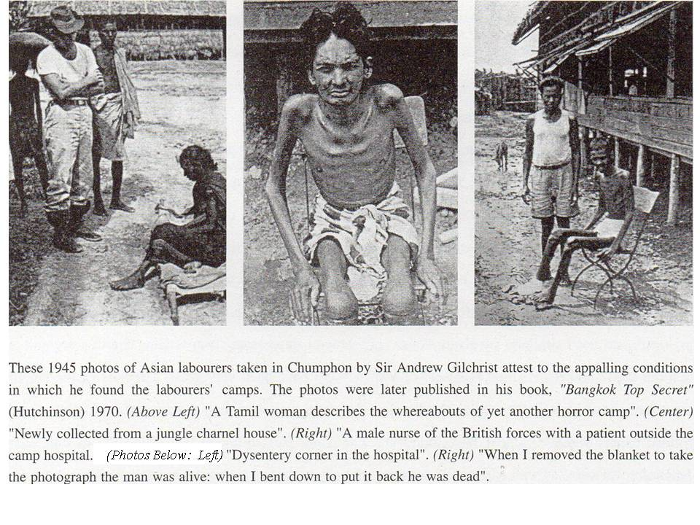
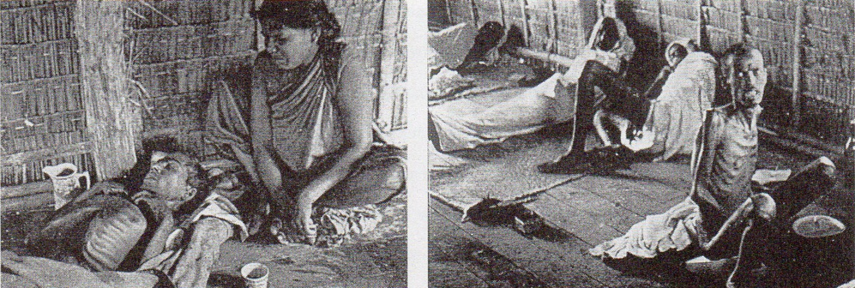

were indescribably filthy and verminous... The Japanese attitude was not so much one of obstruction as of total incomprehension: they could not understand why anyone took so much interest in those miserable creatures.”
Gilchrist included several photographs of these Asian workers in his letter home, five of which are included in his book. They show barely living skeletons, some on the verge of death. One photo caption reads “When I removed the blanket to take the photograph the man was alive: when I bent down to put it back he was dead.” Another photo of a skeletal Tamil woman is labeled, “A Tamil woman describes the whereabouts of yet another horror camp”; that under a photo of an emaciated young man, “Newly collected from a jungle charnel-house”, and yet another, “Dysentery corner in the hospital.” It is clear that he was personally considerably shocked on encountering these survivors.

THE CHUMPHON – MERGUI (MYEIK) ROAD

The railway was but one project to link Burma and Thailand across the narrow peninsula. Towards the end of the war, the Japanese quickly constructed another link in the hope of providing an escape route from Burma for their defeated armies. As Allied prisoners-of-war were used on its construction, the Mergui Road may explain the confusing (and inaccurate) claims of some commentators that Allied POWs had been involved in the construction of the Kra Isthmus Railway. According to Donald Smith’s account in his published memoirs “And All The Trumpets”, several prisoners from the Thai-Burma Railway were used in the building of a road from Prachuab Khiri Khan (some distance north of Chumphon) on the Gulf of Siam through Tenasserim to Mergui (Myeik) on the south Burma coast. Smith was one of those prisoners.
“We did not know that the Mergui Road was merely intended as a back-door through which the broken forces of imperial Japan might yet escape the relentless fury of total war and utter annihilation. It was not wise that we should be told such things... The Railway of Death was a supreme tragedy, cast on tremendous, heroic lines. The building of the Mergui Road in 1945 must always remain, in comparison, an intimate drama, presented by a small cast of tired hut seasoned players... Few men came back from the Mergui Road.”

The road itself was a very basic affair,
“In effect, the road was little more than a sandy track through the jungle, varying in width from 15 to 20 feet. On either side ran a narrow ditch to help drain away the monsoon waters when they came.... By the end of the first week in July, the accursed road had been completed, and a Japanese lorry drove over it from Mergui to the Siamese coast.”
After the road’s completion, Smith’s small group of prisoners were ordered to stay on “as maintenance men, ensuring that the road we had made would not fall into disrepair during the forthcoming wet season.” Despite its interest as a rare description of the Mergui Road, Smith’s account is somewhat problematic and perhaps over-dramatised. It is difficult to gauge any overall statistics from his description but he states that he himself worked alongside Dutch and New Zealanders as well as British prisoners. He apparently found evidence to suggest that a considerable number of Australian prisoners had been similarly involved. An overall general impression from reading Smith’s account is that the total number of Allied prisoners-of-war may not have been very great. The bulk of the labour must have been provided by Asian workers, many of the survivors being among those dejected and forlorn beings whom Gilchrist later found at Chumphon. But, although the Allied POWs and their Japanese overseers (as well as some Korean guards) are portrayed in dramatic detail, Smith’s memoirs do not make any mention whatsoever of any Asian labourers. Nevertheless, his account of the Mergui Road is important for detailing some of the smaller, and now all but forgotten, Japanese military construction projects. His account of one of the camps, Maudung, is particularly vivid:

“Maudung had come to he called Death Valley. The name was well deserved. More men had died at Maudung than at any other camp on the Mergui Road. Death struck every hour of the day and night. Prisoners perished not so much from any single definite disease, but from the crushing combination of many diseases – dysentery, beri-heri, septicemia and spinal malaria. It was a camp of the walking dead. The camp stood on a little wooded promontory, from which a flight of broad earthen steps led down to the river. As at Chungkai, the huts had once been lofty, but through wind, weather and general neglect, they had become sadly dilapidated. In many places the bamboo sleeping platforms had entirely collapsed, and men lay on the ground on a tangled bed of dusty laths and withered attap. One of the huts had become so infested with bugs and lice that it stood empty, its inhabitants preferring to lie in the open, under the shade of an adjacent banana-grove. A few men were still able to move slowly as far as the cook-house and back but the majority lay inert, staring stupidly into space with eyes which had lost both luster and interest. It was more than a man could stand to look at those human skeletons overlong.”

The bulk of the labour must have been provided by Asian workers, many of the survivors being among those dejected and forlorn beings whom Gilchrist later found at Chumphon. This is confirmed by another account; that of Albert Edward George Raven (formerly a member of the 18th Division, Royal Corps of Signals), While Raven’s account confirms Smith’s description that the conditions faced by those working on the Mergui Road were far worse than those pertaining on the Death Railway, he provides some important background information. Raven was one of a party of 1,000 “light sick” POWs who were gathered from the men at Nakhon Pathom and sent to the Kra Isthmus to complete the building of the Mergui Road.

“Various sections of the road had been completed by native labour. Our task was to link up the various sections and finally link up with the Mergui end. There were no natives left on the road - they had all either died or run away….The beginnings of an awful truth behind this project had been nagging at my thoughts all through the march, and then it flashed. This was to be a one way road not, as we thought, a supply road for the Japanese in Burma. We had been prisoners for so long and our senses dulled that it hardly seemed feasible that the Japanese offensive in Burma could so quickly be turned into a retreat. They were retreating headlong before the victorious Allied Armies and this road was to be an avenue of escape. Hence the urgency of this task and the need for its completion before the monsoon season in July.”

Albert Raven’s scant information does, however, suggest an extremely unpalatable possibility. Who were the dying “natives” that Sir Andrew Gilchrist encountered in the Chumphon camps? The construction of the Kra Railway through relatively flat and inhabited countryside could hardly have produced such human wrecks as described by Gilchrist, however harshly they may have been treated? Both Smith and Raven tell us there were no Asians working on the road, but Raven states that the road construction had been begun by Asian workers. Gilchrist’s Chumphon “natives” had probably been literally worked to their deaths on the Mergui Road and, when weakness and disease rendered them no longer able to engage in productive labour, they were removed from the Mergui Road project and relocated to the Chumphon base camp. Hence the need arose to replace the “native labour” with that of relatively healthy POWs! Needless to say, such speculation must remain highly hypothetical, for the truth and total numbers of the original Asian workforce will now never be known.

Raven also notes that despite the harsher conditions on the Mergui Road in terms of food, sanitation, housing and complete lack of medical facilities,

“Our guards, mostly Japanese, were less harsh in their treatment of us than those on the railway. Gone was the sadistic outbreak of violence, the bashings and kickings, but they were never lenient.”

Albert Raven was fortunate to be permitted to try walk back to Nakhon Pathom, due to his severe malarial condition. Despite his agonies, he does note the incidence of Allied bombing along his return journey.

“We finished the road and took a well-earned rest waiting for the lorries to come from Kirikan (Prachuab Khiri Khan) with food, but it was too late. The monsoons broke and the top slopes of the road became a slipping, sliding quagmire through which no mechanical transport could run…..

“The rest partially revived me and though the fever was still with me I began to take notice of events around me. Kirikan had changed; its hive of activity being replaced by an air of desolation. Frequent air strikes by Allied aircraft had left a train of destruction. Buildings had been flattened and the ground was pock-marked with craters. A few smiling Siamese came over and chatted to us in the universally-used Pidgin English, completely ignoring our guards. They brought us coffee, bananas and tobacco which we accepted gratefully. They told us the news of the end of the war in Europe and the headlong flight of the Japanese in Burma…..

“Fate was with us and we wended our way slowly towards Ratburi (Ratchaburi) and into a scene of utter chaos. The town had been blanket-bombed the previous day. The railway track was the focal point of utter wreckage. The bombers had scored a direct hit on a troop train. Pieces of carriages and metal lay everywhere and a gaping hole presented what had once been the station. A span of the giant steel bridge that carries the railway over the river was missing and hastily erected to bridge the gap was a crazy, swaying, narrow bamboo construction…. The remainder of that journey was a haze. We passed through the old staging area of Ban Pong where so many of us had camped when we first came to Thailand. We stopped at Non Pladuk (Nong Pladuk Junction) – scene of the disastrous bombing by Allied planes early in 1945 where so many were killed. I remember being propped up on the parade ground at Nakhon Pathom. I awoke in hospital two days later. I was alive! I had beaten the combination of the Japanese and spinal malaria. The nightmare of the Mergui Road was over.”

The present military government not only changed the country‘s name from Burma to Myanmar, it has also renamed most of Burma s cities, towns and villages, causing considerable confusion to outsiders unfamiliar with the country. For the sake of clarity, this article retains the old names commonly used in documents covering these events. Wherever possible, the new names have been inserted in brackets.
The locomotives displayed at Chumphon are; (i) A 4-6-2 Baldwin Pacific built in the USA in 1926. (ii) A 4-6-0 engine built by the North British Locomotive Co. in 1919. (iii) A small 0-6-OST engine built at Bristol (England) in 1897. The Kra Isthmus Railway apparently used the same locomotive types as were employed on the later Thai-Burma Railway. These would have included, besides C56 locomotives from Japan, both British- built 4-6-0 engines already in use on the Thai railways and 4-6-2 types moved by the Japanese from Malaya. Interestingly, there are two C56 locomotives formerly used in Thailand now in Japan: both were found at the Chumphon yards. C5631 (Japanese wartime number) is now displayed at Yasukuni Shrine in Tokyo, the controversial site that enshrines the spirits of Japan’s war dead (including Class A war criminals). The other, C564, is still operating on the privately-owned Oigawa Tetsudo (River Oi Railroad) in Shizuoka Prefecture.
Details about the Chumphon Youth Brigade Memorial are taken from a Thai-language book issued to mark the fiftieth anniversary of the war and published by the Nakhorn Sri Thammarat local administration. The Chumphon monument is explained in detail in a chapter entitled ‘Anuson Sathan,’ (Memorial Sites); pp.158- 161. I am indebted to Thanawalai Jaroenjangdang, formerly a student of both Seika and Chiangmai Universities, for translation assistance, and to Viwat Sritrakul (Seto Masao) of the Bangkok Asahi Shimbun (Newspaper) Office for obtaining copies of this important document. The fighting in Chumphon and other areas of the South ended when Thai Prime Minister Plaek Phibunsongkhram returned from his most famous “absence” to Bangkok, ordered a cease-fire and went on to negotiate various friendship treaties and agreements with Japan. (More complete details of this history can be found in my previous article “Notes on the Thai-Burma Railway Part VIII; Thai Labour & The Ban Pong Incident:” (Journal of Kyoto Seika University; No.26, 2004).
Praphan Phonsawek: ‘Thang Rotfai Khokhot Kra’ (The Railway at the Isthmus of Kra): Sinlapa Wathanatham (Art& Culture) Magazine; Vol. 12, No. 8; Bangkok, June 1991; pp.104-113. I am again indebted to Thanawalai Jaroenjangdang for translation assistance and to Charnvit Kasetsiri, former Rector of Thammasat University, for obtaining copies of this article, the best overall description of the Kra Isthmus Railway to date. Details on the negotiations and agreements about the railway, as well as the Thai companies who received the Thai government contracts are all taken from this important article.
An edited form of remarks made by Lung (Uncle) Gi Suwawichien (then 68 years of age) to Praphan Phonsawek: op.cit; p.109.
Identification and verification of every steam locomotive preserved in Thailand can be achieved by consulting the thorough and complete listings in K. Ramaer: “The Railways of Thailand” (White Lotus Press, Bangkok, 1994). This invaluable work has been used to verify the histories of all the locomotives mentioned in the article. That displayed at the Khao Fa Chi terminal by the River La-Un is a Japanese-built “Mikado” 2-8-2. Although some 12 Mikados were supplied by Japan in 1942 (later Thai National Railway engine numbers 367-378), this particular locomotive was delivered after World War II in 1947. The postwar Allied Occupation authorities arranged for Japan to supply a further (modified) 70 Mikados - as well as some 30 Pacifics - to Thailand. (The engines were supplied as “war reparations”). By 1950 it is estimated that there were a total of 98 Mikados in use on the Thai National Railway system.
Praphan Phonsawek: op.cit; p.111.
Carl H. Fritsche: “Liberators on the Kwai” (undated private pamphlet available in Kanchanaburi); p.26.
Andrew Gilchrist: “Bangkok Top Secret” (Hutchinson, 1970); pp.224-225. The likelihood that Gilchrist was responsible for the arrest and trial of any Japanese military officials for war crimes is, however, rather small. Following his earlier repatriation from Thailand, Gilchrist spent most of the war in Calcutta, where he worked on supporting and supplying the Seri Thai (Free Thai) Movement that opposed the Japanese presence within Thailand. (His diplomatic career in Bangkok had brought him into contact with - and he was well liked by - both the movement’s leader and Regent of Thailand, Pridi Phanomyong and his remarkable wife). Gilchrist was considerably more ambivalent about the issue of war crimes than the excerpted quotations might suggest. During his lengthy Calcutta sojourn, he had personally witnessed the horrific war-time famine that occurred there due to the negligence of the British colonial authorities, and which had likewise greatly affected him. He was later moved to write, “...if the Japanese had captured Calcutta while the war-time famine was at its height, with innumerable weightless corpses lying about the streets at a moment when no British soldiers were short of rations, might they not have felt justified in putting British commanders on trial as being responsible for this appalling situation?”
It has not been possible to determine which people - if any - were arrested on war crimes charges for their treatment of these Asian workers. However, the Vice Chief of Staff of General Nakamura’s Bangkok Garrison Command, Lieutenant General Hamada Minoru committed ritual suicide on September 17th 1945. Hamada’s death is the subject of Appendix E; “Chumporn & the Death of Hamada”, in Andrew Gilchrist: op.cit; pp.222- 231. A more helpful and informative account of [i-General Ilamadas death can be found in E. Bruce Reynolds: “General Nakarnura Aketo - A Khaki-Clad Diplomat in Wartime Thailand”; and Chapter 6 of Chaiwat Khamchoo & E. Bruce Reynolds (eds.);“Thai-Japanese Relations in Historical Perspective” (Institute of Asian Studies, Chulalongkorn University, 1988); p.189. An excerpt of the latter reads, “The war crimes issue hung like a black cloud over the Japanese, largely because of the mistreatment of 55,000 Allied prisoners of war (POWs) during the construction of the Thailand-Burma Railway. Nakamura’s command had assumed administrative control over the POW camps only in 1945, but Vice Chief of Staff Attaché Hamada had served as head of the POW Information Bureau in Tokyo at the height of the construction and seemed a prime candidate for indictment. Perhaps with this in mind - or as Nakamura interpreted it - to take responsibility for his failure to push through POW camp improvements he had personally advocated - Hamada committed seppuku (ritual suicide) on September 17th” Note 104 of the same work contains more details on Hamada’s background; “Tojo had sent Hamada to inspect conditions on the Thailand-Burma Railway in the Spring of 1943 and what he saw greatly distressed him. As a means to better the situation, he proposed putting the entire railway project under Nakamura’s command. Nakamura, aware of the problem, agreed to the idea and lobbied for its acceptance with the Railway Section Chief of Imperial General Headquarters when he accompanied Tojo to Bangkok. However, the SGA (Southern General Army, head-quartered in Saigon, Vietnam) refused to relinquish its long distance direct control.”
This and subsequent quotations are all from “I Walk With the Ox”; Chapter 4 of Donald Smith: “And All The Trumpets” (Geoffrey Bles, London, 1954); pp.156-193.
Albert Edward George Raven: “The Mergui Road, Burma”; p.4, from the FEPOW (Far East Prisoners of War) Website, https://www.cofepow.org.uk/armed-forces-stories-list/the-mergui-road-burma. I am grateful to Dr. Charit Tingsabadh for drawing my attention to this Important account.
Raven: op.cit.: pp.7-8
Raven; op.cit,: pp. 8, 11 & 12.

