“To get the job done, the Japanese had mainly human flesh for tools, but flesh was cheap. Later there was an even more plentiful supply of native flesh - Burmese, Thais, Malays, Chinese, Tamils and Javanese..., all beaten, starved, overworked and, when broken, thrown carelessly on that human rubbish-heap, the Railway of Death.”
Ernest Gordon, former British POW, in his book, "Miracle on the River Kwai" (Collins, 1963).
“The Sweat Army, one of the biggest rackets of the Japanese interlude in Burma is an equivalent of the slave labour of Nazi Germany. It all began this way. The Japanese needed a land route from China to Malaya and Burma, and Burma as a member or a future member of the Co-prosperity Sphere was required to contribute her share in the construction of the Burma-Thailand Rail Road.... The greatest publicity was given to the labour recruitment campaign. The rosiest of wage terms and tempting pictures of commodities coming in by way of Thailand filled the newspapers. Special medical treatment for workers and rewards for those remaining at home were publicised. Advance wages to provide for the wife and children attracted enterprising labourers from all over the country.... To cut the story short, these terms were never fulfilled.... The local Japanese methods of recruitment were conscription of the most brutal type. The Burmese officers could do nothing about it without risking violence.... There were cases where professional sweat army men could not be obtained. In such cases men were forcibly dragged away from their homes. When they reached the labour camps and had started working, thousands saw neither the much promised clothing and cash, nor the food and medical aid.... These men were taken into malarial jungles without sufficient clothes, food and shelter, and made to clear the wonderful road that was to make Burma (into) a Paradise (as) the terminus of a gigantic Co-prosperity Sphere railway from China.”
U Hla Pe in his account "Narrative of the Japanese Occupation of Burma” (Cornell University, 1961).

“In building the Thai-Burma Railroad, your paper says, 30,000 (Burmese) natives died. Among them were many of my compatriots, Burmese nationals. I still vividly remember mothers, wives, children and other loved ones were left behind weeping silently while men were dragged away by the dreaded Taimen Tetsudo Kensetsu Hoshitai from their homes in many villages and towns in our part of the country. Some of these men escaped, some came back, after months of forced labor, emaciated and afflicted with one kind of disease or another, but many did not return home at all. They were not POWs. They were just ordinary citizens. So, at that fearful time, we used to mumble sadly an ancient Burmese proverb that we were like ‘the grass between two fighting buffaloes.’ Now..., I feel strongly that these poor victimised men, dead and living alike, should also be given a place - a grateful recognition. Merely because they were ‘natives’..., they should not be forgotten, ignored and neglected. Many of them may still be living in Burma and in Thailand. Of course, they do not belong to great nations and big developed countries.
Letter to the Japan Times by a "Burman" datelined Osaka, 1st November, 1976.
“The Japanese forcibly recruited over 170,000 labourers from all over Burma. In order to get the necessary number, township administrative officers cooperated with some politicians in the recruiting. Only a few far-sighted and brave politicians denied this duty. People aged from 13 to over 60 and 70 fled their homes to avoid the recruiting drive. They hid in jungles, pagodas and monasteries. Some starved for days at a time. Recruiting forced labour was like capturing people in every district. Well-to-do people used their wealth to protect their sons, brothers and nephews from becoming part of the labour force. Some bribed the Japanese soldiers, while others found paid money and found someone to go for them. At that time, the going price for a substitute labourer was anywhere from 300 to 500 kyat. All in all the majority of the labour corps constituted village people and unemployed townsmen….
“Meanwhile other group leaders from nearby barracks came with more bad news. More labourers had died (from cholera) and there were problems in burying them. They said more and more people were dying, and those still healthy lived in the greatest fear…. Nobody wanted to carry the dead bodies, and the group leaders were searching for liquor to boost their morale….Then all the group leaders gathered and went to the barracks. I was shocked when I saw the dead bodies of the labourers in all positions of death. Since we could not keep these bodies exposed any longer, we started to bury them. Some labourers dug a big pit for a mass grave. At the same time the bodies were tied together with creepers and vines. While they were doing that we moved to another barrack. I saw three or four bodies being carried out into the forest for burial. Some held torches and accompanied them. They carried the bodies tied up with vines and hung on long poles. It was the most heartbreaking night for me. None of the group leaders and I could sleep that night. Until dawn we had to keep the fires burning and bury the dead bodies.”
Lin Yone Thit Lwin: “Thai-Myanmar Railway; A Personal Memoir (Yodaya-Myanma Miyhta-Lan Kodwe Chwaydat Hmattan), Duwun Sarpay, Rangoon, 1968. Translated by Daw Hmwe in Paul H. Kratoska (ed.): “The Thailand-Burma Railway, 1942-1946” Vol. VI (Routledge) 2006; pp. 42 & 53.

“But with the defeat of the Japanese (the railway) vanished forever and only the most lurid wartime memories and stories remain. The region is once again a wilderness, except for a few neatly kept graveyards where many British dead now sleep in peace and dignity. As for the Asians who died there, both Burmese and Japanese, their ashes lie scattered and lost and forgotten forever.”
Ba Maw in his diary, "Breakthrough in Burma," (Yale University, 1968).

KEY TO THE ILLUSTRATIONS
1. The Thai-Burma border at Three Pagoda Pass; Amphoe Sangkhlaburi.
2. The Three Pagoda Pass; Amphoe Sangkhlaburi.
3. Map correctly identifying the Three Pagodas; Thai Immigration Office notice; Amphoe Sangkhlaburi.
4. The border crossing to Burma (Myanmar); Three Pagoda Pass; Amphoe Sangkhlaburi.
5. A notice advertises distances along the railway on the Burmese side of the border; Phayathonzu. (Mawlamyaing is the contemporary name for Moulmein and Yangon for Rangoon).
6. Ordinary Thai road maps site the Three Pagodas mistakenly. (The correct location is on the promontory slightly north-west of the map's location. See photo 3); "Thailand Highways Map" (Auto Guide Co. Ltd., Bangkok).
7. The railway on the Burma (Myanmar) side of the border; Phayathonzu.
8. Notice in Burmese and English on the Burma side of the border, Three Pagoda Pass; Amphoe Sangkhlaburi.
9. The Wooden road bridge built by ethnic Mon peoples across the north end of the Kao Laem Dam; Sangkhlaburi.
10. Mon religious architecture; Sangkhlaburi.
11. The Kao Laem Dam, constructed in 1985. The railway course lies submerged under the dam; Amphoe Sangkhlaburi.
12. Allied bomb fragments discovered by Wirat Chantera near the Hintok Station site; Amphoe Saiyoke.
13. The restored railway course near the Hin Dat Station site; Amphoe Saiyoke.
14. Temple erected by the ethnic Mon people who had fled to Sangkhlaburi from the Phayathonzu (Three Pagoda Pass) area of Burma; Sangkhlaburi.
15. Mon language memorial inscription on the new concrete bench erected at the Hintok Station site. (The date at the left is in regular Thai letters). Created by Wirat Chantera; Amphoe Saiyoke.
16. The Saiyoke Noi waterfall. The railway course passed directly in front of the waterfall, along the land visible in the photo foreground; Saiyoke Noi National Park, Amphoe Saiyoke.
17. Japanese C56 Locomotive in the livery of the Thai National Railways; Saiyoke Noi National Park, Amphoe Saiyoke.
18. Approaching the Ban Lichia cave; Amphoe Sangkhlaburi. (Photo: courtesy of Pidet Pothamool).
19. Wirat Chantera, ethnic Mon foreman of the Hellfire Pass Memorial Museum's railway course restoration project, near the Hintok Station site; Amphoe Sangkhlaburi.
20. Inside the Ban Lichia cave; Amphoe Sangkhlaburi. (Photo: courtesy of Pidet Pothamool).
21. The entrance to the Ban Lichia cave site; Amphoe Sangkhlaburi.
22. The "train-truck" preserved at Tha Makham, Kanchanaburi. The Japanese designed the truck to run on the rail tracks. At least six were in use on the railway, particularly during the early stages of construction. They were all brought from Japan.
23. Sketch-map allegedly drawn by a Buddhist monk who entered the Ban Lichia cave with returning Japanese. The map indicates the site of treasure, Buddhist statues and graves of Japanese soldiers who allegedly committed suicide in the cave; Ban Lichia, Amphoe Sangkhlaburi.

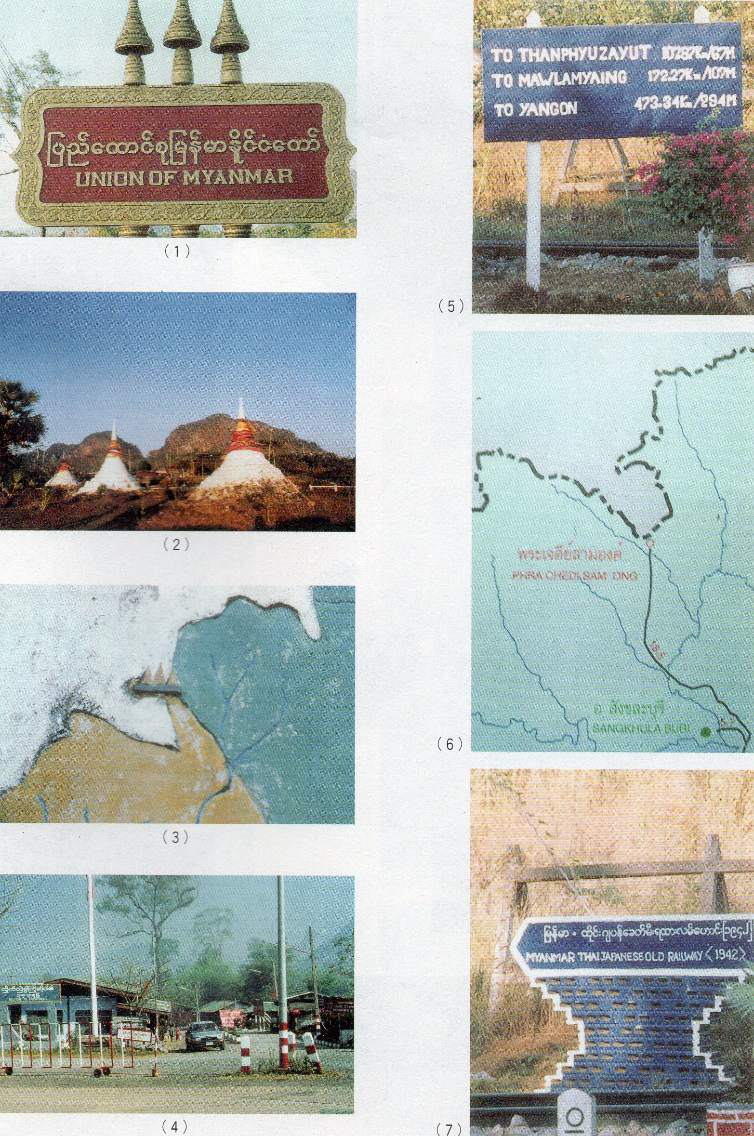
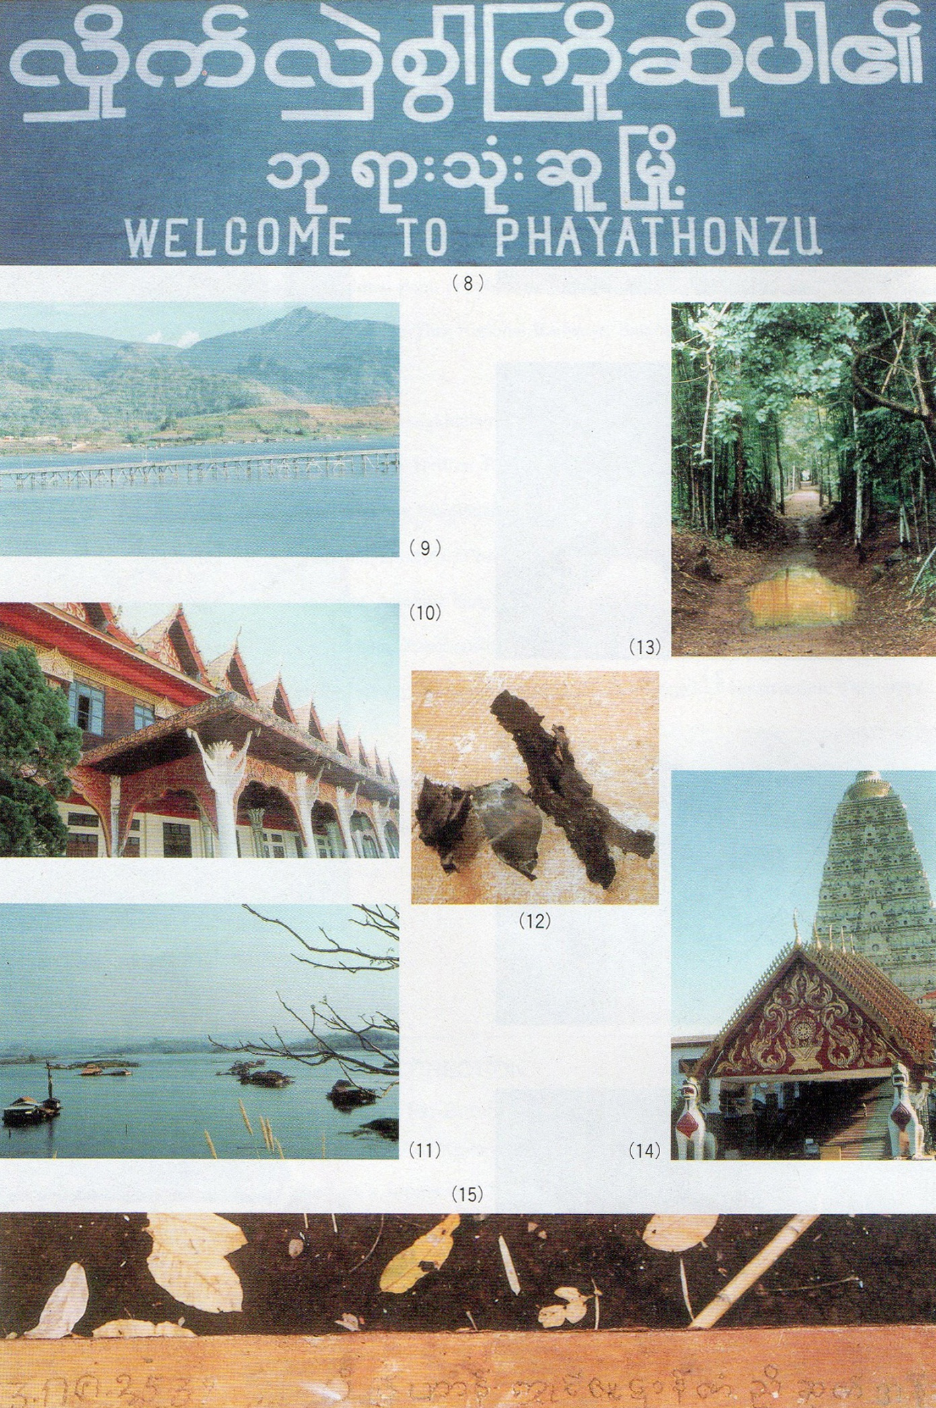
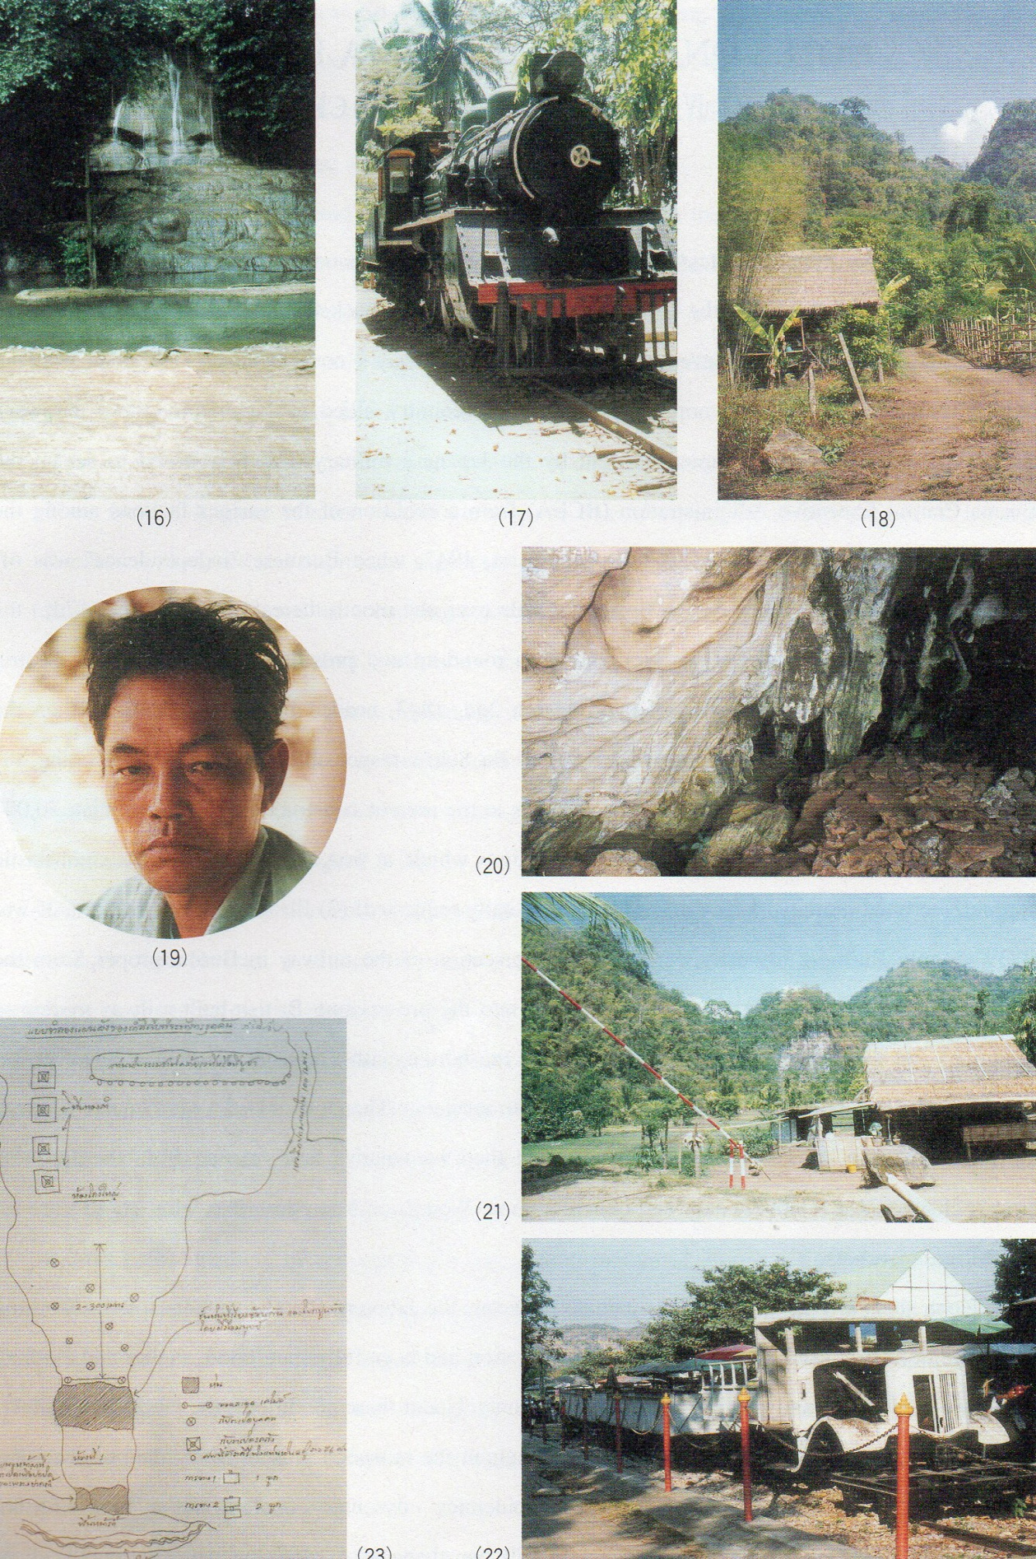
NOTES ON THE THAI-BURMA RAILWAY
PART IV: "AN APPALLING MASS CRIME"
The title, "An Appalling Mass Crime" is taken from comments on the Thai-Burma Railway made by none other than Ba Maw; the Prime-Minister of Japanese- backed "independent" Burma and an initial enthusiastic supporter - even promoter - of the Railway's construction. Unlike Thailand (which remained a more than nominally independent country allied to Japan throughout the war), Burma had been formally occupied outright by the Japanese military, which hastened to set up the Burma Central Executive Administration (BCEA) from a coalition of the various factions among the Burmese independence movement. Until August 1st 1943, when Burmese "independence" was officially proclaimed (the railway was finished a little over one month thereafter, on October 17th) the Japanese simply ordered the (Burmese) BCEA to round-up and provide the labourers. The Central Labour Service Bureau was established on March 2nd 1943, headed by Thakin Ba Sein, then the BCEA's Minister of Transportation and Irrigation. Ba Sein's responsibilities included "recruiting, organising and transporting the Labour Service Corps to the area of construction."
More than 70,000 workers were recruited in three nation-wide campaigns which, at first, due to the BCEA's enthusiastic support, recruited more workers than had been originally requested! Besides Allied prisoners-of-war (POWs), Burmese romusha were used on the section of the railway in Burma proper, from the terminal station of Thanbyuzayat (where it linked into the pre-existing British-built railway system to Rangoon) and the Three Pagoda Pass that marked the border with Thailand. It was, however, inevitable that - compared with romusha impressed into service in Thailand who were unable to speak the local language; for the Burmese, working in their own native land, escape from the Japanese army's clutches was relatively easy and quite common. Won Zoon Yoon describes what lay in store for the Burmese workers;
"Upon their arrival at the labour camps, however, the laborers found that none of the working conditions promised by the Military Administration had been fully met. Food, shelter and clothing were inadequate, and medical supplies were scanty. Under these conditions, the laborers were mercilessly driven into the steaming jungles throughout the monsoon season. Many died of sheer exhaustion and starvation, while widespread epidemics - dysentery, cholera and malaria - further increased the death rolls. Once a man fell ill his chances of surviving were extremely slight because of a lack of drugs. So deplorable were the working conditions that many deserted whenever they could. By the end of June 1943, more than half of the laborers had disappeared, having either deserted or succumbed to hardship and disease.... In order to prevent desertion, the Japanese established a police station at Thanbyuzayat."
The prevalence of disease and the miserable conditions among the Burmese workers is confirmed from the diaries of Allied POWs working on the Burma section of the Railway;
"Someone discovered dead bodies (Burmese natives) in a hut in a bit of a clearing. Almost immediately, the Japanese guards began screaming at everybody to get to their feet and move on. 'Cholera, cholera camp' was heard up and down the ranks."
"Just as we are scheduled to move out from here, cholera has broken out in the Burmese lines. Their lack of hygiene renders neighbours a grave risk of contagion of many kinds of tropical diseases.... However, one unpleasant aspect (of the new camp) is the necessity to share one hut with Burmese labourers, as well as occupying a common kitchen. We soon discovered four of the native coolies were victims of cholera. Isolation of the afflicted was affected without delay."
"The native huts were in such a deplorable way, the Nipponese ordered the Australians to clean them up. A dead native child was found and the Japanese wanted to throw it, and one of their dying members, onto a fire. They refused, even though they were unmercifully bashed for their failure to cooperate with their 'colleagues'."
The attitudes of some Japanese military officials towards these Burmese workers is indirectly indicated by Abe Hiroshi, a second lieutenant in the Fifth Railway Regiment, in his passing observations on Japanese care of elephants;
"The Burmese workers in the Burmese Construction Volunteer Corps were paid one rupee per head per day. We paid two rupees per elephant. Everyone took good care of the elephants. Even Japanese soldiers who beat up Burmese never took it out on the elephants. In the early stages, all our food and equipment came by elephant. We had about ten elephants per platoon."
It comes as something of a surprise that this overall picture of gloom is further expanded in his account of the Thai-Burma Railway by none other than Ba Maw himself. Ba Maw was the head of the BCEA and later Prime Minister of Japanese-sponsored "independent" Burma. He had enthusiastically promoted the railway project in the first place, and still expressed admiration for the railway's achievements on his subsequent escape to Thailand along it on August 15th 1945. Ba Maw's comments, therefore, deserve detailed scrutiny;
"This project, and particularly the way some of the labour employed in it was obtained has become one of the most controversial actions of the Japanese in South-East Asia.... Thakin Ba Sein, the Labour Minister, took charge of our part of the job... Our political organisation, the Dobama Sinyetha Asiayone, took an active part in the drive for recruits. Permanent inspectors as well as periodic inspection teams composed of high Burmese officers, including ministers of the government, visited the construction area and also the recruiting grounds from time to time and reported the conditions. For example, at the end of 1942 Thakin Mya, the Deputy Prime Minister, and Thakin Ba Sein visited Thanbyuzayat, where the new railroad started.... Meanwhile, other inspection squads composed of ministers, secretaries of the government, permanent labour officers, and leading politicians like Ba Hein, a frontline communist, toured Pegu and Insein districts to whip up recruitment.... The first period was rich in dreams as well as in actual work done, but the price the Burmese people were paying for it was staggering. Upon their arrival the men were at once swallowed up by scrubby, steamy, malaria-infested land inhabited only by a few wandering jungle-dwellers, and there they had to rebuild their lives and homes in an aboriginal emptiness. At the end of the first stage of the project a good part of the jungle had been cleared and tamed, but more than half of the labourers had disappeared, having either fled or been killed off like flies by black-water fever, the deadliest form of malaria, and other jungle- camp epidemics.... Those labourers, who knew they were doomed to die... are now unknown, unhonoured, and unsung, and even unburied in filthy graves. Not even a solitary post stands to this day to tell later generations where their bones lie.... There were also numerous small out-of-the-way camps where conditions continued to be most primitive and even brutal. These small camps lay within the deep jungle and were inaccessible to our labour officers and the visiting inspection teams. The Japanese superintendents in those unvisited spots were in many cases war-brutalised men who drove the workers like slaves, seized whatever they needed for their work from the neighbourhood often without giving sufficient compensation, and behaved thoroughly like slave-drivers.... There is yet another side to the picture, an even more brutal one for the Burmese workers and their families in general. For them it was a total exile from their life-long homes, from which they were suddenly uprooted and hurled into an utterly unknown region. That was cruel enough, but the way it was done to a large number of them was so foul that it became one of the most abominable crimes committed on the people during the war... The worst part of it was that the principal criminals were some of the Burmese themselves. The central government had enforced a system which gave the whole power of recruitment to the local Burmese administration.... Out of this system, which was really intended to protect the Burmese, there grew a colossal racket, particularly in areas remote from central control.... If the local Burmese officer who received the request happened to be corrupt, he would make up a list for each town and village under him, taking care to enter into it all his enemies and also some of the wealthiest inhabitants, who could be squeezed to pay the largest bribes. The list would contain more people than the required number in order to give a wider range for blackmail; then those people would be told of their fate. There would be a mad rush to get out of the list, and in the end those who bribed most would succeed in doing so. If as a result the total number of labourers needed was not obtained the bums and tramps in town would be rounded up, appeased with a small payment, and packed off with secret instructions to take the first chance to run away before reaching the construction camp. One labour officer told me that three-quarters of the recruits did not arrive at the camp. Even press gang methods were employed by both Burmese and Japanese recruiting officers in the neighbouring districts to waylay people and drag them away by force. The racket reached its peak in the latter part of the war when the number of recruits arriving at the destination in a fit condition for work was kept permanently low by the recruiting officers so that the lucrative game might be kept going.... All that most of the Japanese labour officers bothered about was to get the right number of workers: they did not care how it was done, particularly when the Burmese themselves were doing it. So the racket went on in one form or another throughout 1944 and has left behind the most indelible memories among the people."
As the above comments were made by one of the Railway project's foremost Burmese supporters, one shudders to imagine the total extent of the suffering. What of the results of this massive labour drive? The Japanese Military Administration itself estimated Burma's rice paddy crop in 1942-43 at a half the normal yields: although there were doubtless various contributory factors,
"The shortage of agrarian manpower needed for rice cultivation was largely caused by the compulsory recruitment of Burmese peasants to engage in Japanese military projects such as bridge repair, road maintenance, railway and airfield construction and to work in factories, mines, harbors, and other military installations. For a single project of building the Burma-Thailand Railway, for instance, some 85,000 (sic) Burmese, mostly peasants, were forcibly recruited by the Japanese Military Administration."
Frank Trager's volume of translations from Japanese military documents relating to Burma includes one entitled "Summary of Organizing and Dispatching of the Labor Service Corps for the Construction of the Burma-Thailand Railway," issued by the Commander of the Hayashi Army Group on March 2nd 1943. The document's stated objective was,
"To organise and dispatch a Labor Service Corps for the building of the Burma-Thailand Railway, to assist its construction work, and to achieve its rapid completion."
The document was clearly in response to the Army's orders to bring forward and accelerate completion of the Railway. Probably realising that the appalling working conditions had made recruitment of further Burmese workers particularly difficult, the document is extremely detailed in its provisions for treatment of Burmese workers. Significantly, Section IV, "Directions for Use of the Labor Service Corps," includes the following provisions;
“1.Corps members shall not be treated as common laborers as in the past. The term “coolie” shall be strictly prohibited. “2. They shall not work in the same working area as existing labor groups. “3. Responsible Organizer: The head of the executive administration (BCEA).”
The newly-recruited Labor Service Corps members were, clearly, to be isolated from and, hopefully, remain in ignorance of the dreadful state of the earlier workers and their camps. Recruitment of the Corps continued to be left in the hands of the BCEA (Burma Central Executive Administration). Section II, "Organizing the Labor Service Corps" states,
“Labor Service Corps' organizers shall select members from young and able Burmans in every district throughout Burma."
Dispatching the Labor Service Corps, again makes the BCEA responsible for transport and delivery of the workers to assembly points, usually Thanbyuzayat,
“Transporting procedures are as follows: the executive administration (BCEA) shall take responsibility for transporting the Labor Service Corps members to the organizing place.... Other matters shall be dealt with by the executive administration."
The document clearly indicates that local "defense troops" were to be actively involved in supervising the labourers. These troops were local Burmese soldiers, now renamed as the Burma Defense Army, formerly attached to Aung San's Burma Independence Army. (Following the earlier training of Aung San and other leaders on Hainan Island by the Japanese military, the Burma Independence Army had fought alongside the Imperial Japanese Army in its attack upon Burma in 1942.) For example, Section II, item 9 of the Document reads,
"Commanders of the defense troops shall assist in organizing the corps."
Section III, item 3 (d) also mentions the defense troops in a curious combination;
"The commander of the defending troops and the Military Police Corps (Kempeitai) concerned shall also assist in transporting corps members."
Presumably the combination of Burmese troops (who spoke at least the majority Burmese language) and the Kempeitai was an attempt to prevent worker desertion en route to the camps. But the involvement of the Burma Defense Army personnel in the supervision of the Burmese romusha, brought them into direct contact with the miserable situation and atrocious conditions which the labourers were facing. This was to have important repercussions a year later.
Further detailed instructions on worker treatment from the same document reflect rather more about the conditions of earlier Burmese workers, for they were enunciated in order to alleviate the worst excesses prevalent until that time. Section IV contains the following provisions,
"5. Proper working hours shall be set up and extreme overwork shall be avoided. “6. Lodging, supply and sanitation facilities shall be fully equipped. Special efforts must be made to maintain self-sufficiency for the corps. The Military Railway Unit shall be responsible for the above, but other military authorities shall assist the unit....
“8. Efforts must be made to maintain good contact between the corps members and their families."
Section VI, "Salary" provides for an unspecified "monetary allowance" being given to Corps members and item 2 states,
"The family of the corps member shall be provided with a security fund."
Finally, in Section X, entitled "Other Matters" the following curious provision appears as item 2;
"The executive administration (BCEA) shall make every effort to send civilian consolation units in order to encourage corps members. Other encouraging measures shall be considered."
It is doubtful whether the Japanese military - its resources much strained by 1943 - was able to implement many of the above conditions under which the new Labor Service Corps was to be created. Nevertheless, that the Japanese military was aware of the unpopularity of its enforced romusha service among the Burmese is significant and some small efforts may have been made to ameliorate the workers' conditions of service. Ba Maw himself fled from Burma along the Railway on August 15, 1945 and records some positive impressions of labourers' villages he passed. He was surprised to hear at one such village near the Thai border that the romusha had no wish to "return" to their home areas,
"I then looked at the little village more closely. Only then did it strike me as a surprisingly well- built and well-organised group of huts, many of them with a small garden plot bright with monsoon flowers or filled with rows of vegetables. The jungle had gone, and there was a tiny pagoda, a school, and even a make-shift dispensary. I asked the obvious question about malaria and epidemics, and they replied that there was very little of them now. The men, women, and particularly the children looked healthy, well fed, and well clothed."
Nevertheless, that such Japanese administrative documents remained chiefly paper provisions is clear from the general account of U Hla Pe, the Director of Press and Publicity in the Ba Maw government from 1942 to 1945. His account, "Narrative of the Japanese Occupation of Burma" was delivered verbally to his old school friend and successor, U Khin, Press Officer to the postwar (British) Government of Burma. U Khin kept notes of the conversation which were eventually published in March 1961. Due to the long elapse of time before the Narrative was finally published in English, there are several obscure points of grammar and even some contradictory or repetitive statements. The following is an excerpt of part of U Hla Pe's account. (Editorial corrections or additions are indicated by brackets);
"(The) Burmese Government's Labour Officers were not allowed to visit camps in the interior. Burma in all her history had never witnessed anything more appalling in the treatment of human beings. Women labour was also recruited for labour or for rape. Brothers of women, who were outraged, were either shot for protecting their sisters or left to die a slow death in the Tenasserim jungles, where the annual rainfall is about 280 inches per annum. Two young officers of the Government however had the opportunity of visiting as far as the 173rd Kilometre from Thanbyuzayat for which reason alone they were detained for nearly four months in the interior of (Thailand's) forests. It was with the greatest of difficulty that their release from 'duty' was obtained.... These malaria-stricken officers came back with harrowing tales of their experiences. Their first words were 'Please do something quick or there will be a people's revolution.' For months labour conscripts had had no-one to whom they could lay their grievances. They were dying like flies from disease and starvation. When these two officers returned to Rangoon, they were politely warned that any report of the true state of affairs might involve them with the Japanese Military Police. Like true sons of the soil, they ignored the threats and gave a first-hand account to the Government. It was nothing new. It was a confirmation of the so-called rumours about the evils of the Labour Campaign. District Officers were forced to 'recruit' men to a slow and lingering death. If they did not, the Japanese reported non-cooperation. If they did, the Political Army (Dobama Sinyetha Asiayone) reported to the Government that they were ill-treating the Burmese.... District Officers were under investigation all the time. Even the sleeping hours were not their own. Zealous Japanese officers would call on District Officers at any time of the night and ask them for assistance: how they retained their sanity is a marvel....."
The "Manifesto of the Anti-Fascist People's Freedom League" was circulated secretly in August 1944. It signaled Aung San's and the Burma Defense Army's abandoning its alliance with Japan and stated, "The Burmese Army should revolt and conduct guerrilla warfare against the Japanese." Before the widespread circulation of the Manifesto, the Burma Defense Army had already attacked the Japanese garrison at Pegu towards the end of March. The AFPFL Manifesto clearly indicates forced labour as one of the important grievances against the Japanese. The Manifesto's introduction, "Drive Away the Fascist Japanese Marauders," is worth quoting at length,
"We the people in Burma are at present suffering under the iron heels of the Japanese Fascists. The peace and security of our hearths and homes are in constant danger. We are daily being ill-treated by Japanese Military Police, Japanese soldiers, Japanese merchants and their agents. Our properties are confiscated; we are driven out of our houses. The sanctity of our religious places is being daily violated.... The modesty of our womenfolk is being outraged. Our food-stuffs are being looted by the Japanese. Our country's produce is being exchanged with worthless Japanese currency. Our bullocks and cattle, our motor-cars and carts are being commandeered. Our men are being commandeered for forced labour and our condition is no better than that of animals." (Italics added).
Elsewhere, in item 5, the Manifesto comments on education,
"Education of the type given by the Japanese, which makes the students spies and forget their national language, should be condemned."
Finally, in the Manifesto's "Programme of Action", labourers are again mentioned; several items are instructive,
“1. Destroy the various transport facilities of the Japanese and set fire to their stores. “2. The labourers should not assist in the construction of roads. They should stay away and later rise up in revolt.
“3. Hide your bullocks and cattle, boats and carts from the Japanese.
“4. Kill the Japanese agents and betrayers of our national cause."
Won Zoon Yoon further elaborates,
"(The railway project) also cost Japan immensely, for the resentment of the Burmese toward her grew more intense during the construction period. Many Burmese were becoming more convinced that the Japanese were relentless slave masters rather than liberators."
Ba Maw, too, makes a similar observation while - to his credit - at least accepting some personal responsibility for the disaster,
"(The railway project) was remembered so searingly by so many in the country that the political parties which had actively taken part in the recruitment tried to scuttle out by laying the whole blame on me personally as being the head of affairs at the time. I have refused to deny my guilt, for I was indeed guilty according to the constitution, although in no other way. I have accepted the accusation and abuse as an act of expiation for my inability to prevent such an appalling mass crime."
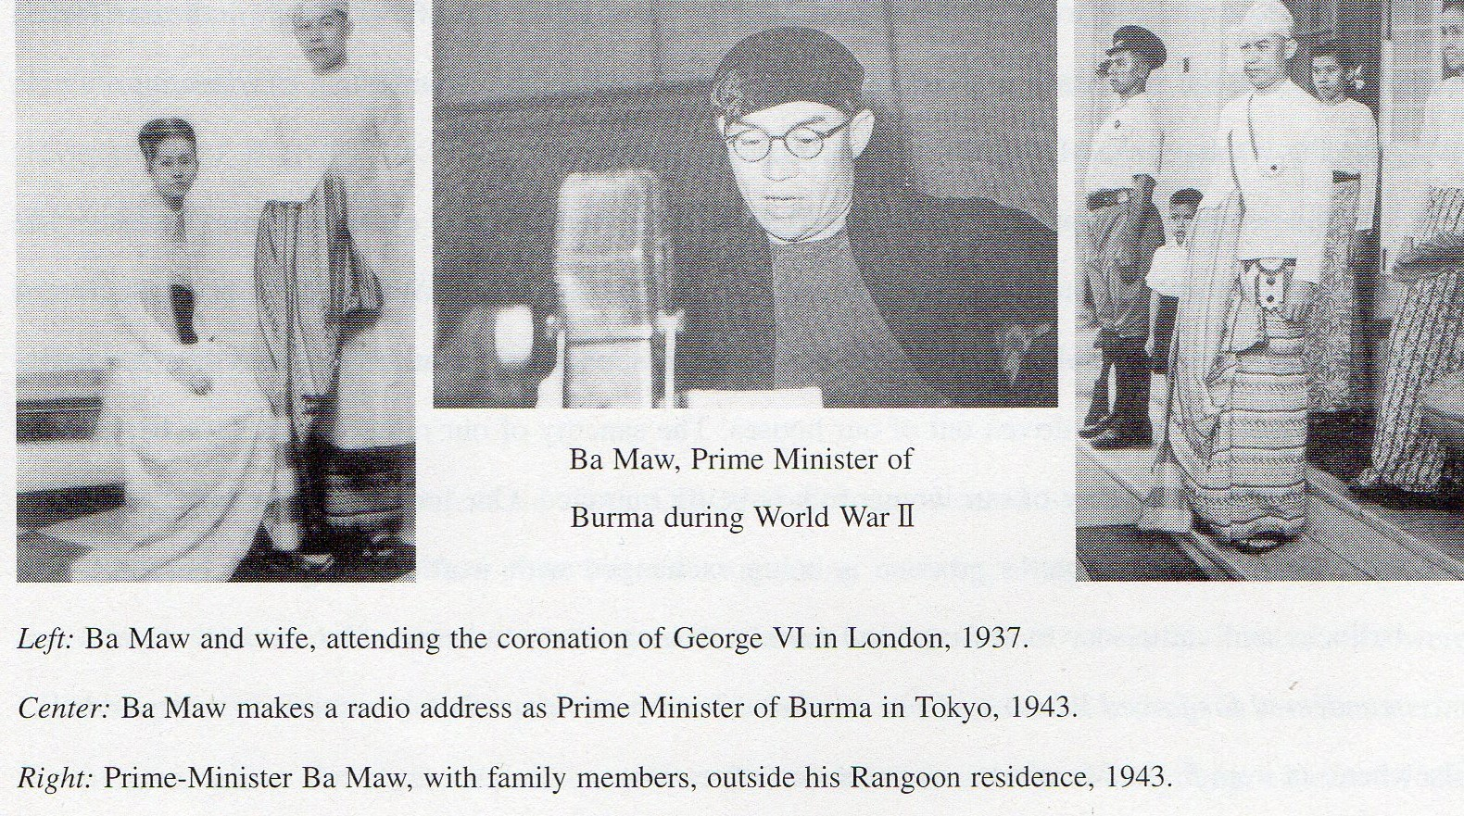

THE THREE PAGODA PASS
As perhaps befitting the main Burmese invasion route to Thailand (and vice-versa), a somewhat ominous and eerie atmosphere pervades the Three Pagoda Pass at the Thai-Burma border today. Strangely, nearly all Thai road maps mark the Three Pagodas inaccurately; rather than being within an area of Thai territory continuously delineating a straight section of border (as the Thai maps indicate), the Three Pagodas are actually situated on a thin sliver of land - at most 200 metres wide - that juts out from Thailand into - and surrounded on three sides by - the present territory of Burma. The only accurate maps seem to be those available at the nearby town of Sangkhlaburi. Until 1990, the Burmese side, Phayathonzu, was a "liberated" area held by the local Mon people. When the Rangoon government recaptured the area (through military action) in February of that year, many Mon fled into Thailand augmenting the substantial Mon community there (and creating a sizeable ethnic Mon village on the outskirts of Sangkhlaburi). Proudly waving an old map - allegedly of European colonial origin - which located the Three Pagodas entirely within Burmese territory, the Burmese military also seized the opportunity to further reduce the tiny sliver of Thai territory, and advanced their border post some hundred yards or so up the road! Interestingly, when the Australian government started to clear some four kilometres of rail-bed around the area of former Hintok station for walking access, the local foreman of the project, Wirath Chantera, an ethnic Mon, claimed that he had had to round-up Mon workers to clear the old rail-bed as Thais were unwilling or unable to do the heavy work involved. In order to commemorate the Mon contribution, a brief sentence in Mon script was carved into a bench at the old Hintok station.
Strange tales and weird stories, freely mixing ghosts of the past with those of the present, abound at the Three Pagoda Pass. On a visit early last year, the senior Thai immigration officer talked of issues, still unresolved, related to the Railway. Prior to his present post, this officer had been attached to the immigration office at Nongkhai, on the Mekong border with Laos; he thus recognised and conversed fluently himself in the Lao dialect standard around the Vientiane area. Shortly after arriving at the Three Pagodas immigration point, he was surprised to be confronted by a group of fluent Lao speakers; they claimed they were Laotians from Vientiane who had been moved to Phyathonzu through working on the Thai-Burma Railway. (Nongkhai is connected by rail with Bangkok through a branch of the North- Eastern line). It was unclear to the officer whether they had been forcibly mobilised as labourers by the Japanese military, or whether they had worked in differing capacities on the completed Railway. Stranded in Phayathonzu at the war's end, the group declared they all still had relatives in the Vientiane area and were anxious to return there. How many such Lao workers still remain is unknown; the group variously mentioned both "several" and "many"! Needless to say, the Thai immigration officer could not cross the border to investigate further; neither would enquiries by other foreigners be likely to reveal very much.

BAN LICHIA: THE TREASURE THAT NEVER EXISTED - OR DID IT?
"One of the most fascinating legends to emerge... has Japanese soldiers burying plundered gold near Three Pagoda Pass at the war's end. So great was the belief in this rumour in the late 1960s that the Governor of Kanchanaburi complained about treasure hunters ruining the environment"
Fascinating, no doubt; but these legends had also led to deaths; doubtless the most recent victims of the Thai-Burma Railway. On July 25th 2000, the Bangkok Post reported;
"Six treasure hunters died from suffocation on Saturday when searching in a cave in Sangkhlaburi district for gold they believed was hidden there by Japanese soldiers during World War II. Police retrieved the bodies of four men and two women from a small narrow cave.... Mr. Sanchai said he and Mr. Sanong followed the six from afar and could not catch up with them. As they went deeper inside they had trouble breathing because the air was so thin and had to come out."
The six had perished in a cave at Ban Lichia, a few kilometres from Sangkhlaburi along the road to Ongthi in Thong Pha Phum district. In 1985, a large dam was constructed on the Kwae Noi, flooding the entire area, from a little beyond Ban Ongthi to just before Sangkhlaburi; the railway course became submerged below the waters of the Kao Laem Dam. There had been caves enlarged along the hillsides into which trains could enter to escape the increasingly frequent Allied bombing; in one such cave, a group of Australians had located the Japanese C56 locomotive now displayed near the Tha Makham Bridge. The Ban Lichia cave is in a small hill a few hundred metres' distance from the dam. Some locals claim that this cave had also been connected with the main railway by a siding line. A visit to Ban Lichia early last year revealed a great deal of activity. Following the six deaths narrated above, high- level government officials had become interested in the cave and a Bangkok-based company had been employed to blow the cave open to solve the mystery once and for all (and, hopefully, gather up the treasure contained therein!). There were even notices claiming that royal permission had been obtained and the area was patrolled by Forestry Department guards. Among items on public display was a sketch- map drawn by a Buddhist monk who had allegedly entered the cave, indicating the location of the treasure, the graves of several Japanese soldiers and even an old aeroplane! Several rumours were told of the gold's "moving" in the cave several years ago, "causing great rumblings that could be heard as far away as Sangkhlaburi." Other tales claimed that two other locals who had entered the cave had been afflicted by "evil spirits"; as a result, one became a monk; the other went mad, unable to speak!
Subsequently, chance remarks with Lt.Col. Terry Beaton, curator of the Hellfire Pass Memorial Museum, elicited that he had visited a similar cave in the same area in the 1990s when dealing with preparations for the museum's construction. Although unable to recall the name, his photos taken on that visit established beyond doubt that it was the same Ban Lichia cave. The stories told at that time were, however, significantly different. Some ten years ago - so the stories then went - a group of elderly Japanese (presumed to be ex-soldiers), together with some younger men, arrived in army trucks with a great deal of equipment (presumed to have been loaned by the Thai army). The group located and confirmed the hill cave using old black-and-white photographs and maps they had brought with them. They had worked in the area, exploding the cave's entrance (perhaps the origin of the "rumbling" rumour) and using a great deal of equipment, for three days, during which the local villagers had been kept away at gunpoint. On the morning of the fourth day, the villagers found that the Japanese group had completely disappeared, silently leaving during the previous night. The visit to Ban Lichia suggested, on reflection, that there may indeed have been treasure stashed away by the Japanese in the cave, but that - if so - it had long been recovered by the Japanese themselves (substantial commissions no doubt going to the Thai military without whose permission and assistance such large recovery operations could not have been undertaken). The embarrassing publicity that shortly thereafter overtook Ban Lichia could, therefore, hardly be considered particularly surprising,
"Prime Minister Thaksin Shinawatra set off Friday to investigate a senator's claims that he has found a fortune in gold stashed in a cave by retreating Japanese soldiers after World War. Senator Chaowarin Latthasaksiri announced late Thursday that, after years of searching, he had finally located the treasure in Li Jia (Lichia) cave in western Kanchanaburi Province. Although his claims were met with skepticism, Thaksin said a senior regional police officer had confirmed to him that 2,500 tons of gold and precious items had been found. 'To my knowledge, a lot of gold has been found over there; police have confirmed that they have found the gold', Thaksin told reporters before departing to meet Chaowarin at the site."
A later report was headlined "Red-faced Thaksin halts search for fabled booty" and informed the expectant public,
"The Thai government was facing serious embarrassment Wednesday as it halted the search for billions in reputed World War treasure amid growing evidence of a huge hoax."
An article in the Nation newspaper was quoted, headlined, "Thaksin exits cave; enters the real world", which editorialised that the incident has "exposed our chief executive to a new wave of international ridicule and criticism." The article continues,
"(Senator Chaowarin) said an antique treasure map had led him to 2,500 tons of gold, loaded into railway cars and surrounded by skeletons of Japanese soldiers who had committed suicide. The horde also supposedly contained $25 billion in U.S. treasury bonds.... On Tuesday, Latthasaksiri (sic) gave Thailand's Finance Ministry a document purporting to represent the $25 billion in U. S. bonds supposedly retrieved from the cave. But a regional U.S. secret service official debunked the document as 'fictitious', saying U.S. treasury bonds had never been issued in denominations greater than $1 million. 'This in no way represents what a genuine U.S. bond would look like,' the official said after examining a copy of the document."
The next day, the bewildered public learned,
"The Thai senator at the center of a $25 billion U.S. bonds hoax that severely embarrassed the government may face arrest, Prime Minister Thaksin Shinawatra said Thursday."
The following day, the story's emphasis shifted yet again,
"Police arrested a Filipino man, identified only as William Morales, accusing him of being part of a gang which brought the fake bonds with a face value of $24.7 billion into the country. 'Police early today arrested William Morales, who acted as a dealer for the gang helping lure potential buyers', Deputy National Police Chief Gen. Sant Surutanond told reporters. Sant told reporters police were hunting for four more foreign suspects and had set up a task force to find the rest of the gang. 'We want to sweep away all these people who are fooling people both in Thailand and overseas.' Police said they were investigating whether the suspects were linked to similar scams in the Philippines, where attempts to sell crude fake U.S. bonds have also been foiled. The third Filipino suspect to be arrested claimed to be an adopted son of the late Philippine president, police said."
As if fact and fiction had not already been sufficiently obfuscated, the legends received yet a new twist in August 2001, with the serialisation by Thailand's Channel 7 television station of a fantasy "docu-drama" based on the Ban Lichia treasure fiasco. Entitled "Khum Sap Mae Nam Kwae" (The Hidden Treasure of the River Kwae), the August 13th episode showed Thais, Burmese, Japanese, madmen, monks, corrupt soldiers and crooked policemen - a fairly unsavoury collection of humanity - diving to find old maps hidden during the war in the brickwork of a temple now submerged at the bottom of the Kao Laem Dam, followed by several dramatic and complex murders to prevent knowledge of the map's existence spreading further! Doubtless further flights of fancy were to be exposed in forthcoming episodes; hardly the most dignified epilogue for "that human rubbish-heap, the Railway of Death."

Ba Maw: "Breakthrough in Burma,’" Yale University Press, 1968; p.297.
Won Zoon Yoon: "Japan's Occupation of Burma, 1941-1945," New York University Ph.D. Thesis, 1971; p.221.
Ba Maw: op.cit; pp.290-292. I have noted elsewhere that the numbers of Burmese workers involved was probably considerably larger than those noted in the excerpts. (David Boggett: "Asian Labourers: The Silenced Voices of History"; Journal of Kyoto Seika University No.20, 2000).
Won Zoon Yoon: op. cit; p. 221. The independent status of Thailand presented the Japanese military with certain complications. An early attempt to use Thai labour on the first section from the Nong Pladuk terminal ended in the disaster of the Ban Pong Incident of December, 1942, in which Thai labourers joined in an attack upon the Japanese garrison stationed at Wat Don Tum (Temple) in Ban Pong. Thereafter, Thai workers were enlisted in much smaller numbers. Hence the enormous use of romusha from other areas - Java, Malaya, French Indochina etc. - on the Thai section of the railway.
Leslie Hall: "The Blue Haze; POWs on the Burma Railway," Kangaroo Press, 1996; entry on "Meiloe (75 Kilo) Camp"; p.142.
Leslie Hall: op.cit; entry on "No.1 Mobile Force"; pp.254-257.
Leslie Hall: op.cit; p.160.
Abe Hiroshi: "Building the Burma-Siam Railroad" in Haruko Taya Cook & Theodore F. Cook: "Japan at War: an Oral History," New Press, 1992; p.101. Lest Abe's remarks be interpreted as suggesting that the Japanese military were conscientious in their handling of elephants (as opposed to people), attention is drawn to the observations of U Toke Gale, who worked throughout his life with Burmese elephants, both before and after the war; "In 1942, just before the war, the total strength of elephants owned by the timber industry of Burma was about l0,000. 6,500 of these were full-grown animals used in the actual extraction of teak and hardwood logs.... By the end of the war in 1945, only about 2,500 full-grown animals, less than one half of the prewar strength, were available for the extraction of timber.... It was said that during the period of the war from 1943 to 1945 many of the timber elephants died of overwork and under-nourishment, while some died at the hands of Japanese soldiers who shot them indiscriminately for their handsome tusks.... And during their retreat into Laos and Thailand in 1944-45, the Japanese army took away some timber elephants to transport their loot and war material. In fact, the first job of work I was offered soon after the war was to recover some of these elephants in the north-eastern jungles of Burma which border on Thailand, but as the remnants of the retreating army were still resisting the Allied troops in those hilly areas, I was unable to organise a party to recapture these stray animals.... It is incredible that such a large number of giants should vanish so completely within a short span of three years.... I remember in 1943-44, while I was girdling teak trees in the Kawlin-Wuntho area in northern Burma, the Japanese army was ostensibly constructing a fair-weather airstrip in Indawgyi. About six timber elephants were employed as steam-rollers, bull-dozers and graders, all rolled into one. These elephants were made to drag large logs up and down the patch of clearing, from dawn to mid-day, with hardly a break in-between. The work was performed in the hot months of March and April, with no trees to give any resemblance of shade, except a few toddy palms that fringed the airstrip, and no water of any kind within a radius of half a mile. There would be a break-off from noon to close on four o'clock.... And then from four in the afternoon to far into the night, the elephants went on endlessly again, dragging heavy logs up and down the strip. No elephant could be expected to survive long under such conditions." U Toke Gale: "Burmese Timber Elephant"; Trade Corporation, Rangoon; probably ca.1968; pp.85 & 86).
Ba Maw: "The Thai-Burma Railway"; op.cit; pp.289-297.
Won Zoon Yoon: op. cit; pp. 210-211. The total figure of 85,000 Burmese labourers is misleading. I have recorded elsewhere that a Burmese romusha who subsequently became a respected novelist in postwar independent Burma, Lin Yone Thit Lwin, has estimated the total number of Burmese labourers was more likely around 120,000. (See David Boggett: op.cit; Journal of Kyoto Seika University, No.20, 2000).
Frank Trager (ed.): "Burma: Japanese Military Administration, 1941-1945" (University of Pennsylvania, 1971); Document No.66, pp.232-236. The translation is from the original "Tai-Biruma Rensetsu Tetsudo Kensetsu Hoshitai Hensei Haken Yoryo" included in Ota Tsunezo: "Biruma Ni Okeru Nihon Gunseishi no Kenkyu" (A Historical Study of the Japanese Military Administration in Burma); Yoshikawa Kobunkan, Tokyo, 1967; pp.520-521.
Compare, for example, the extremely terse and general orders for the original labour recruitment, "Summary for the Construction of the Burma-Thailand Railway," instructions from the Imperial General Headquarters to the Southern Forces, June 20th 1942, translated as Document No.65 in Frank Trager (ed.): op. cit; pp.231, 232. Japanese original in Office of War History, Defense Training Institute, Defense Agency "Biruma Koryaku Sakusen," Asagumo Press, Tokyo, 1967; pp.486-487.
"Consolation Unit" is the normal translation for "imondan," units which catered for more normal troop recreation and included popular singers, well-known performers etc. to entertain the troops (or, in this case, labourers). It should not be confused with the controversial "yangjo" (comfort stations), whose purpose was to force women - usually, but not always, Korean women - to provide sexual services for Japanese troops. There is ample evidence of the existence of such comfort facilities in Burma; many diaries of both Allied soldiers and former POWs mention Korean women and some describe what was clearly a "comfort station". There were also repeated complaints about the Japanese military's treatment of Burmese women. Nevertheless, I have found as yet no suggestion that the "consolation units" mentioned might also have included any people forced to provide sexual services.
Ba Maw: op. cit.; pp.296-297.
"U Hla Pe's Narrative of the Japanese Occupation of Burma", recorded by U Khin; Data Paper No.41, Southeast Asia Program, Cornell University, 1961; p.20.
The full text is available in Maung Maung Pye: "Burma in the Crucible," Khittaya Publishing House, Rangoon, 1951; Appendix I, pp.177-183. Maung Maung Pye states that the Anti-Fascist People's Freedom League (Burma Patriotic Front) included the following groups; "The Burma National Army, the Communist Party, the People's Revolutionary Party - later known as the Socialist Party - the East Asia Youth League, a considerable section of the Mahabama Organisation, the Myochit party, the Sanghas' Asiayone and the Karen, Shan, Kachin, Chin and Arakanese communities": op. cit.; p.82.
Paradoxically, while the Manifesto urges the killing of those (Burmese) who collaborate with Japan (in which role - it might be added - Aung San himself and the Burma Independence Army had been cast from 1942 to 1944!), the Manifesto urges, "If you come across individual Japanese soldiers, do not kill them but win them over to our side," for - a footnote explains - "The Japanese Fascists are not only ill-treating Burmans and other Asiatics but also their own countrymen in Japan. The Japanese labourers are being exploited and maltreated. The Anti-Fascist elements are imprisoned." The AFPFL's policy towards Japanese soldiers is something of a contrast to that adopted by the invading British forces under General Slim! But, in the extremely strict - and somewhat paradoxical - statements about Burmese collaborators and those who cooperated with Japan, it might not be too far-fetched to detect some of the early causes of the debilitating factionalism that beset the politics of post-independent Burma, a factionalism which some would claim to have been in no small measure responsible for the distressing situation of contemporary Myanmar today.
Won Zoon Yoon: op. cit; p. 225.
Ba Maw: op.cit; p.295.
Named Phra Chedi Sam Ong in Thai and Phayathonzu in Burmese (both names literally meaning the Three Pagodas), the pass was the normal invasion route to Thailand for Burmese troops until 1767. Later in 1785, a younger brother of King Rama I led a Thai army to victory over the invading Burmese of King Pradung. In 1942, the pass was again one of the major invasion routes into Burma for the Imperial Japanese Army.
Writing nearer the time of the Burmese military activity when local memories were still fresh, Christian Goodden records, "However, the Burma Army, far from crumbling, held on to the pass area. It did not even completely withdraw from 'Thai' territory, but held on to the Three Pagodas, claiming that they belonged to Burma. To back up their claim, the Burmese produced an old British colonial map showing the pagodas inside their country. While they were there they gave the ancient venerated chedis a coat of white paint, ironically using Thai paint to do the job. The following day an incensed Thai nation awoke to see pictures of marauding gun-toting bandanna-clad Burmese infantrymen roaming around the freshly whitewashed pagodas. Needless to say, the Burmese were soon dispatched from regular Thai soil, but they were not entirely removed from the pass." Christian Goodden: "Three Pagodas: A Journey Down the Thai-Burmese Border"; Jungle Books, Halesworth, 1996; pp.269-270).
As the immigration officer is a Thai Government official, courtesy requires that he not be mentioned by name.
Though not an expert linguist, it should be noted that the Vientiane dialect of Lao seems quite distinct to the untrained ear, to that - say - of Luang Prabang, further north. To Laotians - as opposed to foreigners - these dialects are more or less mutually intelligible. The point here is that the immigration officer, having previously worked at the border with Vientiane, was fluent in the language spoken around Vientiane and able to assert with complete confidence the provenance of the language spoken by the people who had approached him.
The possibility of forced labour from former French Indochina has already been mentioned with regard to Vietnam. David Boggett: "The Silenced Voices of History"; Journal of Kyoto Seika University, No.20, 2001.
Micool Brooke: "Captive of the River Kwae," Merman Books, Bangkok, 1995; p.82. Brooke also mentions, "Another version concerns a Japanese aircraft that crashed in the wilderness of Mount Pilok, near Thong Pha Phum... in January 1943." All twelve people on board, including Lt.-Gen. Shimada Nobuo, Commander of the 9th Railway Regiment, were killed in the crash, excepting one, "sparking speculation that the lone Japanese survivor buried gold bullion in the jungle before seeking help from Thai villagers. The rumour was so strong in the early 1980s that the Japanese embassy sent two officials to investigate the crash site. The embassy remained tight-lipped about what the officials found but it is known that they returned with war relics, including the general's sword, several submachine guns and a coin." Micool Brooke: op. cit.; p.83.
Preecha Srisathan: "Kanchanaburi: Six Die in Gold Hunt," Bangkok Post, July 25th 2000.
David Boggett: "'The Bridge on the River Kwai' - The Movie."; The Journal of Kyoto Seika University, No. 19, Kyoto, 2000. Viwat Sritrakul / Seto Masao, photographer of the Japanese Asahi Newspaper’s Bangkok Office, clearly recalls visiting such a cave himself at around the same time and distinctly remembers that the rail tracks within the cave were still in existence.
Personal interview with Lt.Col.Terry Beaton, Curator of the Hellfire Pass Memorial Museum; February 2001. It is perhaps not insignificant that Rod Beattie, Supervisor of the Commonwealth War Graves Commission's Kanchanaburi cemeteries, has found, when investigating stories of "treasure hunters" on the railway, that the rumours often returned to groups of elderly Japanese who were presumed to have been soldiers in the Imperial Japanese Army; personal interview with Rod Beattie; January 2001.
In this respect, it is interesting to note that a number of memorials recently constructed by the Japanese in the area (such as the "Peace Park" just outside Kanchanaburi town) have involved the expenditure of a great deal of money. It is unclear just how this money was obtained. On the Thai side, much speculation surrounds the late General Sunthorn Kongsompong. Besides being a leading member and prime mover of the 1991 coup d’état, General Sunthorn left an enormous amount of unexplained wealth in his will (which is presently being contested by various wives) and is also the subject of an official Government enquiry. The General was also a top-ranking leading military officer at the time of the alleged attempt to recover the Ban Lichia treasure. (See, for example, the Bangkok Post, 29th March, 2001). The Japan Times of 21st April, 2001 (quoting from AFP-Jiji and AP sources) also noted another example of unexplained wealth, "Buddhist monk, Luangta Maha Bau will donate 1 ton of gold in a public ceremony Saturday to Thaksin's government as a public contribution toward the Thai economy." The explanation offered was, "The gold and millions of dollars worth cash has been collected by Maha Bau from the public since the start of the 1997 Asian financial crisis to be used in times of need." It is doubtful whether the truth about the disposal of any treasure lifted from the Ban Lichia cave will ever be known, for Thailand still testifies to the efficacy of an old adage; those who have the money, also have the power.
Japan Times: 14th April, 2001 quoting AFP-Jiji sources. Senator Chaowarin Latthasaksiri is a former Education Minister.
Japan Times: 19th April, 2001 quoting from AFP-Jiji and AP sources.
Japan Times: 20th April, 2001 headlined "Thai senator in hoax may be busted,” quoting AFP-Jiji sources. Also Japan Times: 21st April, 200l; "Thai police arrest another phony bond scandal suspect as gold fever still rages", quoting AFP-Jiji and AP sources. The same article juxtaposes the story of Buddhist monk, Luangta Maha Bau, who was mentioned in note 29 above).

